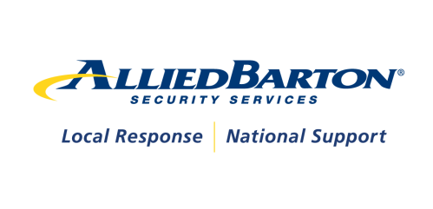

October 16, 2014

Sandra Breiling

**DC Ranch Association**

20555 N. Pima Road

Scottsdale, AZ 85255

Dear Ms. Breiling:

On behalf our Mesa district support team, it is our pleasure to participate in the DC Ranch Association security RFP process.  The enclosed response includes detailed information regarding AlliedBarton Security Services and how we can help you to achieve your security and business objectives.

It is our hope that our strong combination of excellent local management resources, expertise in residential communities and our award-winning learning and development programs will make us the clear choice to be your security partner. In our recent site visit, we got a good idea of how the security program operates and how the security team interacts with the residents, visitors, and vendors. AlliedBarton has experience in gated communities and depth of resources and will share best practices to help make an immediate enhancement for DC Ranch Association.

AlliedBarton is proud to tailor its services specifically to meet the needs of DC Ranch. Even though we are able to share Best Practices from our many residential clients, AlliedBarton designs the overall security approach to address your community. From our walkthrough, the following areas were discussed, and we have offered some suggestions on how they can be addressed**.**

* **Minimizing Turnover to Foster a Consistent Security Program for DC Ranch**
  + A stable security staff has a greater depth of understanding of your site, and becomes a more reliable presence upon which you and your residents can depend. On the other hand, a revolving door of security officers can signal a problem, is costly and undermines confidence in what should be the perception of a safe and secure environment.
* **Customer Service as an Extension of DC Ranch’s Security Program**
  + Security services do not end with patrols and access monitoring. By the nature of their position, and the respect they command, the security officers at your site can become customer service ambassadors – providing information, greeting guests and serving as a resource. It takes the right officer and the right training for this to be highly effective.
* **Ensuring a Quality Security Program with Measureable Results**
  + If you can’t measure it, you can’t manage it. In today’s business world it’s becoming increasingly important to establish performance standards and measure results. To take your security service to a higher level, we will be focused on quality assurance.

Thank you for extending the opportunity to present the value we can bring to DC Ranch Association. We look forward to having the opportunity to prove our strengths. If you have any questions, please contact me at 323-841-5367 or brian.hampton@alliedbarton.com.

Sincerely,

Brian Hampton

Business Development Manager

|  |  |  |
| --- | --- | --- |
| cid:./uploads/output_cover_residential.png |  | cid:./uploads/g_proposal_output_width.gif  **A Security Partner You Can Trust**  **A Security Program for**  **DC Ranch Association**  October 16, 2014  C:\Users\jefigg\AppData\Local\Microsoft\Windows\Temporary Internet Files\Content.Outlook\5I39EDDP\sign 1.JPG  Presented to:  **Sandra Breiling**  Director of Security  DC Ranch Association  Presented by:  **Brian Hampton**  Business Development Manager  AlliedBarton Security Services    cid:./uploads/image/ABSS_logo.png |
| This security services data, furnished in connection with a request for information, shall not be disclosed in whole or in part to any third party. This restriction does not limit the right of DC Ranch Association to use information contained in the data if it is obtained from another source without restriction. | | |

**Table of Contents**

[Executive Summary 4](#_Toc401045171)

[*AlliedBarton Understands DC Ranch’s Needs and Priorities* 4](#_Toc401045172)

[*Minimizing Turnover* 4](#_Toc401045173)

[AlliedBarton Overview 15](#_Toc401045174)

[Mission Statement 16](#_Toc401045175)

[*Sustainability* 20](#_Toc401045176)

[Pricing 23](#_Toc401045177)

[*Pricing Notes* 27](#_Toc401045178)

[Human Capital Management 29](#_Toc401045179)

[*Screening* 32](#_Toc401045180)

[*Retention* 33](#_Toc401045181)

[*Turn-Over: Profit at Risk* 34](#_Toc401045182)

[*Benefits* 35](#_Toc401045183)

[Security Operations 40](#_Toc401045184)

[*Supervision and Management* 40](#_Toc401045185)

[*Scheduling* 41](#_Toc401045186)

[Training 43](#_Toc401045187)

[*MSO Level I - Essentials Orientation* 45](#_Toc401045188)

[*MSO Level I - Practical Application* 45](#_Toc401045189)

[*Driver Training Course* 51](#_Toc401045190)

[*Master Security Officer* 52](#_Toc401045191)

[*Specialized Training Tools* 52](#_Toc401045192)

[*Supervisor’s Workshop* 53](#_Toc401045193)

[*Operations University* 54](#_Toc401045194)

[*Security Academy in Leadership* 54](#_Toc401045195)

[*Dare to be Safe!* 55](#_Toc401045196)

[Quality Assurance for DC Ranch 57](#_Toc401045197)

[*Performance Measurements* 58](#_Toc401045198)

[*AlliedBarton|Support Center* 60](#_Toc401045199)

[*Net Promoter Survey* 60](#_Toc401045200)

[Technology 62](#_Toc401045201)

[*Business Continuity* 62](#_Toc401045202)

[Uniforms 65](#_Toc401045203)

[References 69](#_Toc401045204)

[DC Ranch Transition Plan 71](#_Toc401045205)

# C:\Users\jefigg\AppData\Local\Microsoft\Windows\Temporary Internet Files\Content.Outlook\5I39EDDP\sign dc1.JPGExecutive Summary

As the leader in providing security services to the residential market since 1957, AlliedBarton understands the competencies and customer experience that DC Ranch seeks from its security partner. By partnering with a provider servicing thousands of clients with needs similar to yours, a comprehensive security program will exceed your security and safety needs. ***Well trained, well prepared, responsive, customer service oriented and respectful security officers and supervisors will represent and enhance the DC Ranch brand.***

## *AlliedBarton Understands DC Ranch’s Needs and Priorities*

We know that in order to provide outstanding, consistent service we must exceed your expectations. You have shared with us your goals and objectives for your security program. We understand that training and development for the team at all levels is important so they can always perform at the top of their game. Additionally, support for DC Ranch’s team in terms of administrative, human resources and training assistance will allow you to focus on other areas that are critical to the community.

We believe the security program can benefit by providing employees with a path or “roadmap” for advancement both financially and professionally which will result in improved retention and ultimately better service. This proposal aims to address several elements that must be contained in a successful security program. We are aligned with you and ready to move into action minimizing turnover, increasing customer service and offering a quality security program as highlighted below.

### *Minimizing Turnover*

***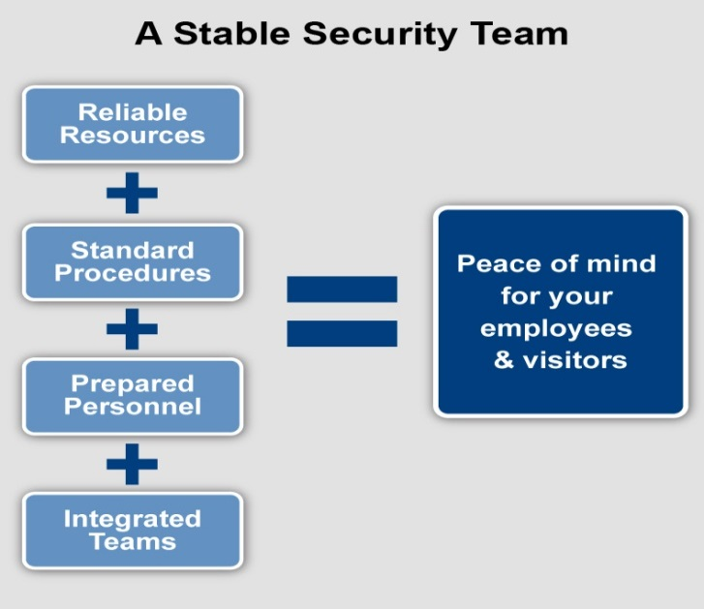***An effective security program is about just one thing: great people. Everything we do at AlliedBarton ultimately comes down to finding and retaining the right officers and managers. We maintain staff turnover at an absolute minimum thanks to superior recruiting, screening, and officer selection, and continues through training and ongoing development.  
The elements of staffing stability are complex, and include adequate wages and benefits, proper hiring, competent supervision, comprehensive training, employee recognition, opportunities for advancement and on-going performance evaluations. AlliedBarton is proud to have one of the lowest turnover rates in the industry locally and on a national level.

**Screening - Identifying the Right Employees** - Because we are so demanding with the caliber of employee we accept, screening is critical. Qualified candidates formally interview with our district recruiter to find exact matches for our clients. Our comprehensive approach to screening includes:

* Application Review & Assessment
* Interviews
* Education and Employment Verification
* I-9
* Criminal Background Checks
* Social Security Checks
* Pre-employment Drug Testing
* Motor Vehicle Report
* Management Testing

**Meaningful Benefits** - Employees at all levels deserve benefits that contribute directly to quality of life. Comprehensive benefits are part of the AlliedBarton experience.

* Medical, Dental and Vision Insurance
* Disability and Life Insurance
* Pay cards or Direct Deposit
* Blackstone Market Place
* Paid Vacation
* 401 (k) with company match
* Legal Service
* Holidays

**Training for Success**  
The AlliedBarton|**EDGE**® [Educate, Develop, Grow and Engage] is our proprietary training and development program. It includes our Learning Management System (LMS) which provides AlliedBarton employees with on-demand access, through *e*Learning, to modules that prepare them for future responsibilities and career opportunities. Our experience shows that virtually every measure of security officer quality can ultimately be tied back to the quality of our training program.

AlliedBarton|**EDGE** goes beyond traditional training, all the way to enhanced course offerings, additional compliance functionality and more opportunities for employee growth. AlliedBarton|**EDGE** is comprised of a nationwide network of more than 100 trainers; online, classroom and self-study training; a mentoring program; industry-specific and leadership training; and multiple other learning and development programs. For more information about the AlliedBarton|**EDGE**, go to [www.AlliedBartonEDGE.com](http://www.alliedbartonedge.com/).

AlliedBarton officers undergo extensive and continuous training to prepare them for the unknown and the unexpected. Site-specific and on-the-job training ensures each officer is fully educated per your requirements. The AlliedBarton|**EDGE**® is our comprehensive approach to training and a critical AlliedBarton advantage.

* All your officers will be CPR/AED/First Aid trained.
* All your officers will be Master Security Officer I trained.
* All your officers will have 24 hours of on-the-job training and 8 hours of refresher training.
* Our vast range of courses includes Master Security Officer levels 1 -5, Safety Officer Specialist, Terrorism training, industry-specific School of Residential Security course, and leadership training.
* All training is tracked electronically and available online for client review.

Damien Willis, local certified district trainer, is a dynamic trainer and will provide assistance with training and development on a quarterly basis to help your team with site specific issues, concerns, and new trends at DC Ranch Association. This training will focus on specific areas of importance to you ensuring that we are providing relevant training that can make an impact for the community. We will focus on our **School of Residential Security** and **Master Security Officer** certification programs. These will address higher level training needs for customer service while preparing the team to take the next step in their security career. More details about our training programs can be found between pages 36 and 48.

**Leadership Development**

The demands are high for the security program at DC Ranch Association. This program requires a high level, sophisticated Account Manager with the ability to manage up, across and down appropriately.

We will develop and mentor the Account Manager to enhance his ability to interact with homeowners as well as multiple layers of community groups and law enforcement. By being more proactive, s/he can take the initiative to communicate with you to present issues, while suggesting solutions and following up with the results that you expect, allowing you to focus on your job versus managing security.

The Account Manager must also be someone that can attract, develop and effectively manage the best talent. Once hired, it is crucial that we constantly develop our people by creating a custom training plan for the team. Finally, in order to inspect what is expected, this leader must effectively manage individuals to the highest level through motivation and accountability. With a team of this size, it is imperative to groom other reliable leaders and have the ability to delegate appropriately while ensuring quality performance.

**The Right Wages for the Right Officers**

We understand the critical role the security officer plays at DC Ranch in their regular interactions with your residents, guest and vendors. For this reason, AlliedBarton is proposing a starting wage for security officers of $13.00 per hour with the opportunity to advance to $13.50 after six months and $13.75/$14.00 after 12 months, based on criteria set by AlliedBarton and DC Ranch Association management. Criteria will be training and performance based (example: no complaints, appropriate attendance, appropriate incident reporting). This wage will enable the recruitment of quality security officers who possess the Dedication, Security Mindset and Customer Service approach needed to mirror the expectations at DC Ranch. Any agreed upon increase in wages will be honored with established markup proposed.

|  |  |  |  |
| --- | --- | --- | --- |
| **Position** | **Wage** | **Min. Tenure** | Min. Suggested **Training Criteria** |
| Security Officer Level I | $13.00 |  | AED/CPR & MSO I |
| Security Officer Level II | $13.50 | 6 months | Fire Safety & MSO III |
| Security Officer Level III | $13.75 | 12 months | MSO V & 2 EDGE Courses |
| Security Officer Level IV | $14.00 | 12 months | School of Residential Security |

**Recognition and Rewards**

Recognizing a job well done goes a long way. Security Officers often work in repetitive environments where they are more often faced with adversity from visitors versus appreciation for the work that they do to keep a community safe. As this is a reality of the job, it is part of our job to be aware and do our best to provide balance for our Officers with positive recognition. We offer several programs for Security Officers, Supervisors and Managers to nominate one another for doing a GREAT job. We have annual recognition programs on a national and regional level and quarterly on the district level, and feel that it would be important to create a specific monthly recognition program for the team at DC Ranch to include a certificate of achievement and a monetary or gift award. This will motivate the team and create a positive environment and increase retention. A list of established recognition programs are listed on page 31.

**Local Response**  
Jeff Meintel, your local District Manager, is an empowered decision maker who understands your account. He directly supervises and engages with his security team. The mentoring relationships that exist between managers and security officers are instrumental in retaining employees. What’s more, our local managers spearhead employee growth and development to create a team environment and produce consistently excellent security programs.

**Performance Evaluations and Tracking** - Annual employee performance evaluations represent an important component of AlliedBarton’s local management supervision. Our standard evaluation ensures we are living up to our promise of high quality personnel and service.  
  
Performance evaluations are an opportunity to assess performance, suggest improvements, and develop relationships between our courtesy officers and managers. Security officers and managers review a number of job elements discuss career paths, training and employee development. We track performance evaluations through WinTeam, our integrated human resources, scheduling and payroll system.

**On-Site Supervision**- Supervision is another important element for maintaining staff consistency. Our local managers play a vital role in screening officers who may be assigned to your site. A professional, experienced manager has an ideal perspective into the skill level and personality required for a security officer to be successful and motivated. Leadership training for managers reinforces the mechanics of workforce management and focuses on the softer skills necessary to keep employees engaged.

**Employee Retention** - Our approach to improving retention for security officers is centered on empowering employees. On-boarding programs, on-ramp packages for management, training and other employee engagement programs are designed to recognize and retain excellent people.

An AlliedBarton Security Officer has a career. That makes a difference in service and retention. Regional human resource managers focus on employee relations, customer satisfaction and compliance. Our computerized scheduling system helps avoid assigning shifts that are too long or which may be too closely spaced together. Our Security Voice hotline provides prompt attention to officer questions and our employee website, MyAlliedBarton.com, is an outlet for employee suggestions.

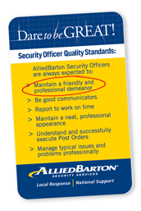

**A Culture of Pride and Accomplishment**  
The core purpose of our Dare to be GREAT culture is “to serve and secure the people, homes and businesses of our communities.” This serves as the foundation of everything we do, connects our family of 60,000 employees, and serves as a rallying point for each of us.

*Customer Service*

The AlliedBarton|**Ambassador**SM program is designed to produce security officers capable of delivering the perfect combination of skill, professionalism and friendly service to our clients’ *customers*. AlliedBarton is leading our industry in formally evolving the traditional security officer role to include a strong focus on customer service. This has proven effective in environments that place a premium on customer service. The program is designed to focus as much on concierge service and a five-star atmosphere as it does first-class security operations. The program relies on specialized recruiting and training.

**Recruiting**  
The AlliedBarton|**Ambassador** program employs a specific set of recruiting requirements that vary somewhat from our normal standard. Our Certified Recruiters focus on locating men and women who may have unique customer service or concierge backgrounds. These candidates must exhibit extraordinary interpersonal skills, perception, and sensitivity.

Because of our recruiting expertise, and our team of recruiters at the national, regional and district levels, proactively identifying candidates for this specialized program is simply a matter of communicating the need and our qualified team makes it happen. AlliedBarton strive to find quality individuals, in 2013 we had the privilege of hiring over 5,000 veterans.

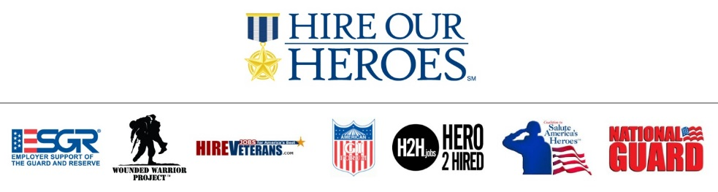

 To ensure high quality employees that are the right fit and have the right skills for your property, AlliedBarton uses an automated, highly customized Applicant Tracking System**,** AlliedBarton**|Gateway**SM. Our easy-to-use, digital platform features:

* **Advanced Filtering:** Utilizing a smart search feature, managers and recruiters are able to search for candidates by shift preferences, ranking, location and other requirements such as a driver’s license. This feature gives our recruiters an edge in identifying a qualified candidate quicker and allows us to meet your needs faster.
* **Paperless Processes:** Pre-employment forms can be completed and stored within AlliedBarton**|Gateway,** making the process paperless. Electronic signature capability allows for a smoother process and shortens the time from application to hire.
* **Transparency:** Candidates, recruiters and hiring managers can view the status of a position or application at any time during the process. This means that any questions you have about your open positions can be immediately addressed.
* **Integration:** Integration with other AlliedBarton systems such as background screening and drug testing, and our careers web site promotes efficiency; ensuring that every step in our extensive screening process is complete and only the best candidates are selected for your location.

**Uniforms**  
When your residents enter your community, they should know by the uniform that the AlliedBarton officer is the person they can turn to for help or information. Our commitment to proper uniforms and appearance is part of our Security Officer Quality Standards - a core element of our culture that our officers strive for every day.

**Customer Relations**

Our goal is to form partnerships with all of our clients. The officers and on-site manager become an integral part of the DC Ranch team; a group upon which you and your residents will come to rely.

The AlliedBarton program demonstrates the complex and multi-faceted role of the security officer. Many security officers are called upon to perform other functions, whether those are part of their official role or not. When your needs for high quality security and customer service are intermixed and equally important, AlliedBarton is the answer.

AlliedBarton will continually look for ways to get involved with the community of DC Ranch and embrace its culture. To do so, we offer a few opportunities to increase customer service by our involvement within the community.

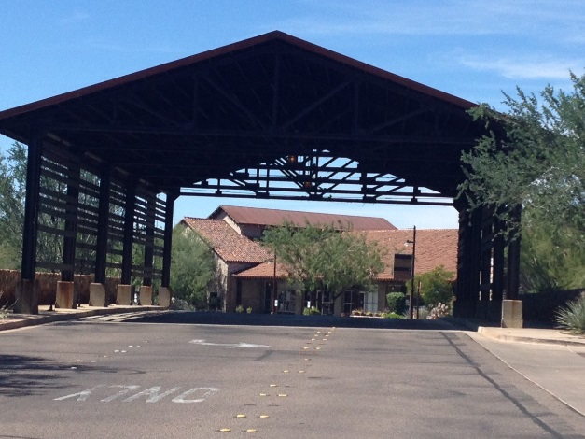**Community Relations and Safety & Security Initiatives** *-* Upon awarding us the DC Ranch Association security partnership, we will organize and execute an open-house reception with food & beverage, to allow residents to meet our team. We can provide safety & security tips for any internal and external communication tools DC Ranch Association may provide its residents.

**Security & Safety Seminars** - AlliedBarton can provide seminars for homeowners on a variety of security-related topics, including Workplace Violence, Workplace Safety, Preventing Identity Theft and other pertinent subjects. AlliedBarton will offer two CPR/First Aid/AED classes (1/2 Day Class) each year at no charge to the Association. DC Ranch Association staff and residents are invited upon direction of DC Ranch Association management. Participants must pay for the cost of the card only ($9-$12.00).

**Security Awareness & Appreciation Events** - AlliedBarton is continuously developing client outreach services that complement your security program. We will do everything possible to foster peace of mind and a sense of security among your residents and guests. This includes participating in a minimum of one community event during the year upon request.

**Safety & Security Awareness Tips** - AlliedBarton publishes a series of Security Awareness Tips, providing insight for individuals on how to protect themselves and their assets. These pamphlets cover a multitude of topics ranging from fire safety and AEDs, to travel security and personal protection.

**AlliedBarton.com** - Our award-winning website is a valued resource for our clients–one that continues to evolve. It provides updated resources for our clients use.

**Performance Management**

AlliedBarton|**Path**®, our performance management software helps our managers effectively evaluate performance - their own as well as their employees’. The program includes online evaluation forms, goal planning and in-person meetings.

Our performance management program is linked to the AlliedBarton|**EDGE**®. By coupling performance management with our comprehensive approach to learning and development, managers can recommend training that will help employees reach their goals.

To increase customer service at any location, it first involves the officers. Our solution involves a wide range process for which has proven to be successful across the country in thousands of locations. Recruiting the right people for the right job is the foundation to excellent customer service. It is enhanced and developed by world class training and managing for success as outlined above. Our solution will lead to increased customer service for DC Ranch Association.

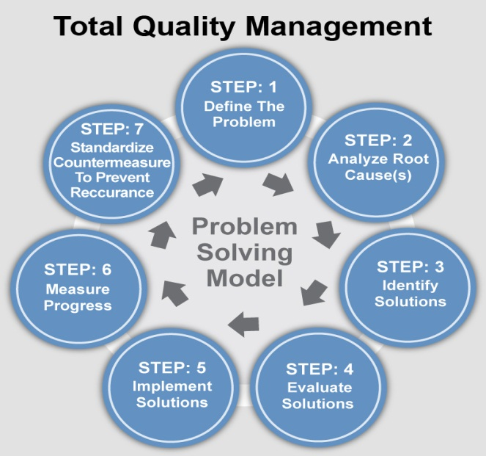*Quality Security Program for DC Ranch*

We consider our clients` needs to be a critical part of our security programs. While we are here to facilitate the program, your expectations, questions and concerns are the foundation for our operations at your site. Our quality assurance initiatives demonstrate our commitment to providing well-trained security officers, hands-on managers, and “getting it right the first time.” AlliedBarton managers are professionals who understand the industry and can competently address any issues that arise or needs that change.

**AlliedBarton|Voice**

You represent an important voice, a critical contributor to the overall development of the security program. Through AlliedBarton|**Voice**, we track your experience as an AlliedBarton client from day one in order to help us deliver consistently excellent service. The program’s hotline, email and online form are all dedicated strictly to clients and staffed 24 hours a day by highly-trained service assurance specialists. AlliedBarton|**Voice** also includes a multi-level structured survey process that encourages ongoing customer feedback and assesses performance. This allows us to identify potential improvement opportunities. **With AlliedBarton|Voice, you will be heard.**

**Quality Assurance**

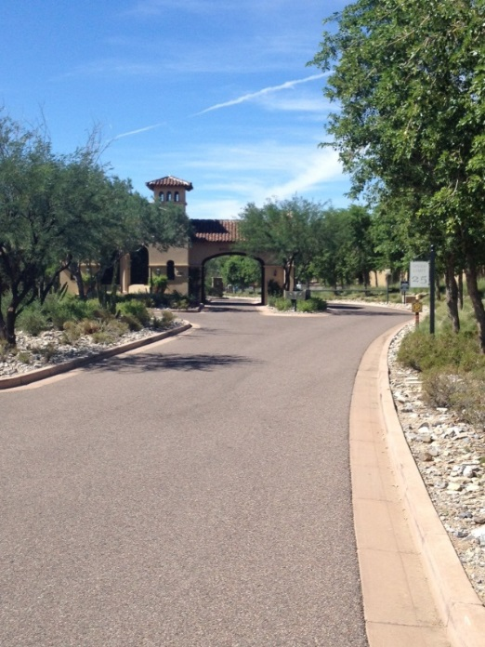Quality is the foundation of AlliedBarton’s security services. It is the factor that consistently differentiates us from other companies, and it’s the primary reason we’re regarded as the industry’s most responsive security services provider.

Our senior management group works as a team in order to develop and implement innovative new programs and operational practices. We use cross-functional teams for special quality-improvement initiatives. District staff works toward the common objective of providing service that exceeds your expectations. Our security officers pledge their commitment to our Dare to be GREAT culture which includes a strong quality component.

**Measuring Results**

We offer the best security programs available. But there is room for improvement in every organization. In order to provide you with the best possible service, we regularly review and measure our performance. Some of our measurements and evaluations include:

* Weekly service hours - OT, billed OT, billed hours
* Employee retention and tenure
* Recognition and rewards
* Training
* Incidents
* Performance evaluations
* Trends
* Customer satisfaction survey results
* Best practices
* Goals and improvement processes

**Quality Business Reviews**

Regularly scheduled assessments are reported and reviewed in meetings between your security management team and AlliedBarton’s local management. These reviews are designed to:

* Review accomplishments
* Create benchmarking for future reviews
* Establish measurable goals

**Experience**

In the state of Arizona we currently service more than 48,000 hours per week of security service. Our experience inside residential communities offers DC Ranch best practice opportunities to increase security. Our experience outside the residential market allows us the opportunity to bring DC Ranch the latest best practices from across the security industry. Our clients range from the Arizona Traditions, the Cloisters at Biltmore, Biltmore Colony Greens, Villa del Oro, Highlands at Dove Mountain, University of Phoenix, Vanguard, Edward Jones, Boeing, Raytheon, the Phoenix Plaza and all the Macerich Malls (Scottsdale Fashion Square Mall) to name a few. Many of these clients recognize excellent customer service as a key element of their security program.

Our expertise in the residential marketplace is second to none. AlliedBarton has a verifiable track record of implementing innovative security solutions to residential communities locally as well as nationally. We have a specialized training certification program that focuses on the unique nature of gated communities. A key part of our program will be this specialized training. The ***School of Residential Security*** is designed to familiarize security personnel with responsibilities such as controlling access, customer service, traffic control, EMS service and special residential populations.

**AlliedBarton services more than 500 communities Nationwide**

**Contract Compliance**

AlliedBarton’s operations staff and Legal Services Group work together to provide effective contract review, administration and compliance. Their objective is to ensure that we meet our contract obligations to the complete satisfaction of our clients.

**AlliedBarton|Support Center**

Our local offices will serve as your primary point of contact. However, the AlliedBarton|Support Center is available to assist you after hours, and for special emergency needs.

**Local Response|National Support®**

We believe in managing the business where the business is. Your local District Manager, Jeff Meintel, is an empowered decision maker who understand your account. He deals routinely with all the operational components that make up a seamless security program. If your needs change, or if you require different services or staffing levels, Jeff Meintel will make it happen.



# AlliedBarton Overview

AlliedBarton is the premier provider of security officers in a variety of markets including commercial real estate, higher education, healthcare, residential communities, chemical/petrochemical, government, manufacturing and distribution, financial institutions and shopping centers. Our unique advantage is an ability to deliver responsive security services at the local level with the benefit of a national support network. More than 60,000 AlliedBarton security officers, managers and support personnel currently serve communities across the United States with reliable protection, customized programs and unparalleled customer service.   
  
**Fast Facts**

* **Award Winning, Quality Training** - AlliedBarton|**EDGE**® is our industry-leading training and development program which includes our Learning Management System providing AlliedBarton employees with on-demand access through *e*Learning. Since the development of the EDGE in 2009, more than one million courses have been completed.
* **Fortune 500 Clients** - Serves approximately 200 Fortune 500 Companies.
* **Professional Personnel** - More than 60,000 professional personnel across the country with industry-leading retention rates.
* **Leading Technology** - Provides industry-leading solutions to augment our best-in-class security officer services and provide you with a complete security program. We have a coast-to-coast wide area network that connects thousands of computers, and provides real-time access to data, management and training systems.
* **National Resources** - Experienced managers in more than 120 offices across the U.S. serve over 3,300 clients. AlliedBarton is the largest American-owned and managed contract security services firm.
* **Focused Expertise** - We provide high quality, dedicated security officers who are well trained and motivated.
* **Safety** - Safety is always a priority in everything we do. When our employees take the lead and work safely, they Dare to be GREAT for your organization.
* **Specialized Services** - We focus our activities in several key industries with specialized services designed for the unique demands of each, including:

|  |  |
| --- | --- |
| * **Residential Communities** | * Commercial Real Estate |
| * Manufacturing and Industrial Facilities | * Healthcare Facilities |
| * Colleges and Universities | * Shopping Malls |
| * Financial Institutions | * Chemical and Petrochemical Sites |
| * Government Buildings |  |

|  |  |  |
| --- | --- | --- |
| ***LOCAL RESPONSE*** | Description: Description: Description: Description: Description: Description: AB_horz_cmyk_img_0  www.alliedbarton.com | ***NATIONAL SUPPORT*** |
| ***AlliedBarton Security Services***  1001 W. Southern Ave.  Suite 235  Mesa, AZ 85210  480-464-4688 | Description: Description: Description: Description: Description: Description: Description: Description: Description: cid:./uploads/image/Supporting%20Content%20Images/Corporate%20office.jpg | ***AlliedBarton Security Services***  Eight Tower Bridge  161 Washington St., Suite 600  Conshohocken, PA 19428  Phone: 484-351-1300 or  888-239-1104  Fax: 484-351-1401 |

Mission Statement

AlliedBarton’s Core Purpose, Core Values and Quality Standards are the driving force behind every decision we make. These critical components of our corporate culture connect our more than 60,000 employees and are the foundation of the quality service we provide to our clients every day. We pride ourselves on being a security partner and an expert resource for our clients. At the core of our success is a quality-oriented Dare *to be* GREAT approach and a focus on local response supported by national resources.

|  |  |  |  |
| --- | --- | --- | --- |
| **ALLIEDBARTON’S CORE PURPOSE** | | | |
| *To serve and secure the people, homes, and businesses of our communities.* | | | |
| **ALLIEDBARTON’S CORE VALUES** | | | |
| **G**rowth | Encourage individual, team, and organizational growth | | |
| **R**esponsibility | Hone our service commitment to customers, employees, and the community | | |
| **E**mpowerment | Offer development programs that enable employees to do their jobs with skill and confidence | | |
| **A**chievement | Reward and recognize service excellence, team success, and individual achievement | | |
| **T**rust | Build trust, respect, and integrity in every relationship and interaction | | |
| **DARE TO BE GREAT SECURITY OFFICER QUALITY STANDARDS** | | | |
| • Maintain a friendly and professional demeanor  • Be good communicators  • Report to work on time  • Maintain a neat, professional appearance  • Understand & successfully execute Post Orders  • Manage typical issues and problems professionally | | Description: Description: Description: Description: Description: Description: Description: Description: Description: Description: Description: Description: Description: Description: Description: Description: Description: Description: Description: Description: Description: Description: Description: Description: Description: Description: Description: Description: Description: Description: Description: Description: Description: Description: Description: Description: Description: Description: Description: Graphic-6a | *Our Core Purpose, Core Values and Quality Standards are printed on pocket-sized cards provided to each employee as a reminder to always Dare to be GREAT.* |

**AlliedBarton’s Commitment to Leadership**  
Many organizations talk about leadership. At AlliedBarton, we are committed to a culture of leadership at all levels of our organization that manifests itself in actions - not just words - day in and day out and ensures the delivery of exceptional security services. Security officers who exhibit leadership qualities instill confidence in those they interact with. In the event of an emergency, a security officer must use his or her leadership abilities to take charge of those affected and ensure their safety. Managers who engage, develop and inspire their security team produce exceptional performance levels, while taking ownership of your concerns and needs.  
  
Throughout our operation, leadership is encouraged, recognized and rewarded. Our recruitment and human capital management processes are focused on attracting, retaining and promoting employees who demonstrate leadership potential. With our Leadership Non-Negotiables as a foundation, we challenge every AlliedBarton employee to accept a leadership role in the execution of their duties. Through a broad array of leadership training and related self-study programs available on the AlliedBarton|**EDGE**®, we encourage our employees to expand their leadership proficiencies as they prepare to advance in their careers.  
  
The security officers and managers across the country who demonstrate strong leadership capabilities at each of our client sites are living our Dare to be GREAT culture.  
  
Whether our clients interact with our security officers or our most senior executives, our commitment to leadership comes through. For your organization, in the communities we serve and in the security industry, our leadership focus results in performance that exceeds expectations every day.  
  
When you work with AlliedBarton, you work with a team that is committed to unsurpassed service and security – anytime, anywhere. You also work with a company that is nationally recognized for excellence in leadership.  For four consecutive years, Chief Learning Officer magazine has awarded us with the Learning Elite Award and we have also been recognized by Chief Executive magazine as one of the top 10 large, private companies for leaders.



*National Coverage*

|  |  |  |  |  |  |  |  |  |  |  |  |  |  |  |  |  |  |  |  |  |  |  |  |  |  |  |  |  |  |  |  |  |  |  |  |  |  |  |  |  |  |  |  |  |  |  |  |  |  |  |  |  |  |  |  |  |  |  |  |  |  |  |  |  |  |  |  |  |  |  |  |  |  |  |  |  |  |  |  |  |  |  |  |  |  |  |  |  |  |  |  |  |  |  |  |  |  |  |  |  |  |  |  |  |  |  |  |  |  |  |  |  |  |  |  |  |  |  |  |  |  |  |  |  |  |  |  |  |  |  |  |  |  |  |  |  |  |  |  |  |  |  |  |  |  |  |  |  |  |  |  |  |  |  |  |  |  |  |  |  |  |  |  |  |  |  |  |  |  |  |  |  |  |  |  |  |  |  |  |  |  |  |  |  |  |  |  |  |  |  |  |  |  |  |  |  |  |  |  |  |  |  |  |  |  |  |  |  |  |  |  |  |  |  |  |  |
| --- | --- | --- | --- | --- | --- | --- | --- | --- | --- | --- | --- | --- | --- | --- | --- | --- | --- | --- | --- | --- | --- | --- | --- | --- | --- | --- | --- | --- | --- | --- | --- | --- | --- | --- | --- | --- | --- | --- | --- | --- | --- | --- | --- | --- | --- | --- | --- | --- | --- | --- | --- | --- | --- | --- | --- | --- | --- | --- | --- | --- | --- | --- | --- | --- | --- | --- | --- | --- | --- | --- | --- | --- | --- | --- | --- | --- | --- | --- | --- | --- | --- | --- | --- | --- | --- | --- | --- | --- | --- | --- | --- | --- | --- | --- | --- | --- | --- | --- | --- | --- | --- | --- | --- | --- | --- | --- | --- | --- | --- | --- | --- | --- | --- | --- | --- | --- | --- | --- | --- | --- | --- | --- | --- | --- | --- | --- | --- | --- | --- | --- | --- | --- | --- | --- | --- | --- | --- | --- | --- | --- | --- | --- | --- | --- | --- | --- | --- | --- | --- | --- | --- | --- | --- | --- | --- | --- | --- | --- | --- | --- | --- | --- | --- | --- | --- | --- | --- | --- | --- | --- | --- | --- | --- | --- | --- | --- | --- | --- | --- | --- | --- | --- | --- | --- | --- | --- | --- | --- | --- | --- | --- | --- | --- | --- | --- | --- | --- | --- | --- | --- | --- | --- | --- | --- | --- | --- | --- | --- | --- | --- | --- | --- | --- | --- | --- | --- |
| |  |  | | --- | --- | | **AL** | Birmingham | | **AR** | Little Rock | | **AZ** | Mesa | |  | Phoenix | |  | Tucson | | **CA** | Foster City | |  | Inland Empire | |  | Los Angeles | |  | Newbury Park | |  | Oakland | |  | Orange County | |  | Sacramento | |  | San Diego | |  | San Francisco | |  | San Gabriel Valley | |  | San Jose | | **CO** | Denver | | **CT** | Bridgeport | |  | Hartford | | **DC** | Washington | | **DE** | Wilmington | | **FL** | Deerfield Beach | |  | Jacksonville | |  | Miami | |  | Orlando | |  | Tampa | |  | West Palm | |  | |  |  | | --- | --- | | **GA** | Atlanta | |  | Savannah | | **ID** | Boise | | **IL** | Chicago | |  | Moline | |  | Naperville | |  | Northbrook | |  | Orland Park | |  | Rochester | |  | Rockford | | **IN** | Indianapolis | |  | Merrillville | | **IA** | Des Moines | | **KS** | Overland Park | | **KY** | Louisville | | **LA** | New Orleans | | **MD** | Baltimore | |  | Silver Spring | | **MA** | Billerica | |  | Boston | |  | Charlestown | | **MI** | Detroit | |  | Grand Rapids | |  | Taylor | | **MN** | Minneapolis/St.Paul | | **MO** | Columbia | |  | St. Louis | |  | |  |  | | --- | --- | | **NE** | Omaha | | **NV** | Las Vegas | | **NJ** | Atlantic City | |  | Lyndhurst | |  | Monmouth Jct | |  | Voorhees | | **NM** | Albuquerque | | **NY** | Albany | |  | Brooklyn | |  | Buffalo | |  | Elmsford | |  | Long Island | |  | New York | |  | Rochester | | **NC** | Charlotte | |  | Raleigh | | **OH** | Cincinnati | |  | Cleveland | |  | Columbus | |  | Toledo | | **OK** | Tulsa | | **OR** | Portland | | **PA** | Conshohocken | |  | King of Prussia | |  | Lancaster | |  | Lehigh Valley | |  | Philadelphia | |  | Pittsburgh | | **RI** | Providence | |  | |  |  | | --- | --- | | **SC** | Charleston | |  | Columbia | |  | Greenville | | **TN** | Chattanooga | |  | Memphis | |  | Nashville | | **TX** | Austin | |  | Corpus Christi | |  | Dallas | |  | El Paso | |  | Fort Worth | |  | Houston | |  | Midland | |  | Kemah | |  | San Antonio | | **UT** | Salt Lake City | | **VA** | Alexandria | |  | Richmond | | **WA** | Seattle | | **WV** | Charleston | | **WI** | Milwaukee | |  | Oshkosh | |

*Communication Infrastructure*

AlliedBarton’s extensive corporate capabilities and resources give our employees–and our clients–a unique advantage. We can deploy talented managers across our more than 120 offices, fully connected and supported with systems, communication, training and best practices. The result is a customer experience that is more responsive, more efficient and more valuable.

AlliedBarton is proud to have a state-of-art communications infrastructure. Our information systems operate on a wide area network that permits our staff to manage our business where the business is. AlliedBarton personnel, including Account Managers, Operations Managers, District Managers and other critical operational resources can access client account files, payroll and scheduling systems, and other important policy and procedure documents as well as utilize email, e-bulletin boards and newsletters. AlliedBarton provides wireless cards for laptops to enhance system availability and communications.

Our Service Assurance Centers operate around the clock to meet client and employee needs. Customer Connection, our continuous improvement and client communication initiative, along with our Service Assurance Centers, and accessAlliedBarton, our technology that can help you to streamline operations, create efficiencies and easily access the information you need, represent our communications backbone.

*Client Outreach*

AlliedBarton is committed to the safety and security of your residents. That commitment is enabled not just by our service offerings and quality officers, but also through timely, valuable information. Our security officers are on a mission to make the world a safer place.

We believe it is our duty to share our expertise and industry knowledge. Part of our customer service commitment is to use our experience to retain quality people, and to keep homes and businesses safe and secure. The following programs represent just a few of AlliedBarton’s efforts to promote security awareness throughout our clients’ sites, the industry and the communities we serve.

**Community Relations and Safety & Security Initiatives** *-* Upon awarding us the DC Ranch Association security partnership, we will organize and execute an open-house reception with food & beverage, to allow residents to meet our team. We can provide safety & security tips for any internal and external communication tools DC Ranch Association to provide its residents.

**Security & Safety Seminars** - AlliedBarton can provide seminars for homeowners on a variety of security-related topics, including Workplace Violence, Workplace Safety, Preventing Identity Theft and other pertinent subjects. AlliedBarton will offer two CPR/First Aid/AED classes (1/2 Day Class) each year at no charge to the Association. DC Ranch Association staff and residents are invited upon direction of DC Ranch Association management. Participants must pay for the cost of the card only ($9-$12.00).

**Security Awareness & Appreciation Events** - AlliedBarton is continuously developing client outreach services that complement your security program. We will do everything possible to foster peace of mind and a sense of security among your residents and guests. This includes participating in a minimum of one community events during the year upon request.

**Safety & Security Awareness Tips** - AlliedBarton publishes a series of Security Awareness Tips, providing insight for individuals on how to protect themselves and their assets. These pamphlets cover a multitude of topics ranging from fire safety and AEDs, to travel security and personal protection.

**AlliedBarton.com** - Our award-winning website is a valued resource for our clients–one that continues to evolve. It provides updated resources for our clients use.The Security Resource Center offers timely information related to today’s security environment, and includes a Security Services Comparison Checklist that allows prospective clients to evaluate multiple service providers during the contracting process. Our industry-specific microsites showcase AlliedBarton expertise and provide users with meaningful, security-related information.

**Community Involvement** - AlliedBarton is an active, responsible corporate citizen and supports numerous charity and community organizations throughout the country. Additionally, our people dedicate extensive personal time and energy to support meaningful causes important to their communities and our clients, including:

* American Cancer Society
* ****American Red Cross
* Catholic Charities
* Cystic Fibrosis Foundation
* Girl Scouts of America
* Big Brothers/Big Sisters
* USO
* Police Athletic League
* Muscular Dystrophy Association
* National Adoption Center
* National Multiple Sclerosis
* Crime Stoppers
* Operation Hope
* Special Olympics
* YMCA

## *Sustainability*

AlliedBarton believes a firm commitment to sustainability means not just developing our own sustainability initiatives, but also helping you achieve yours. Sustainability is a good example of how we can naturally and effectively support many of your other business functions and initiatives, in addition to a safer, more secure environment.

**Our Sustainability Commitment**

Our commitment to respect and utilize natural and human resources effectively is something of which we are very proud. Our sustainability committee ensures our programs touch every level of the company, as well as the communities we serve. AlliedBarton’s sustainability commitment extends beyond environmental concerns to also include socio-economic factors and human capital management.

**Working Together**

Just as we are stewards for our clients’ safety and security awareness programs, we can do the same for their sustainability efforts. This commitment may include any number of projects where AlliedBarton security officers and managers can:

* Enforce policies
* Regulate energy usage
* Provide information
* Utilize energy efficient patrol vehicles

**National Resources**

The combination of local responsiveness and national resources is what sets us apart. Our national support team is in place to lend guidance, training and other resources to local security officers and managers using expertise and best practices in those functional areas critical to security operations. These specialists maintain excellent relationships with local teams, and proactively implement programs and procedures to ensure quality.

**Customized Security Programs**

We will develop a customized program that will ensure your assigned team is the right fit for your organization, and are fully prepared to address your security goals. Everything from recruiting requirements to training and post orders should be developed specifically for you. Because security assignments are developed specifically to meet your needs, adding responsibilities in support of your sustainability efforts is simple.

AlliedBarton is proud to be considered as a partner in reaching sustainability goals for your company.

*Awards*

You need to work with the best security provider, a partner with industry-specific expertise, best practice knowledge and the ability to execute on its promises. Companies that meet those high expectations are often recognized with awards. Awards are viewed as a mark of excellence and are   
an indication of the level of quality you can expect.

**The Most Honored Security Officer Services Company**

AlliedBarton is proud to have taken the lead in many aspects of security operations. Our awards confirm what our long-time clients already know - that AlliedBarton is the leading provider of high quality security services. No other security officer services company has matched the number of awards AlliedBarton has earned.  
  
Even more important are the services that have earned these awards. Our priority is to always provide the best service as we fulfill our core purpose, to serve and secure the people, homes and businesses of our communities.

**Recent Awards:**

* Chief Learning Officer magazine LearningElite Award 2014, 2013, 2012, 2011
* Chief Executive magazine Best Companies for Leaders 2014
* Greater Philadelphia Chamber of Commerce’s Visionary Award 2013
* Brandon Hall Bronze Award for Excellence in Best Custom Content 2013
* U.S. Veterans Magazine, “Best of the Best,” Top Veteran-Friendly Company 2013
* Military Spouse magazine Military Spouse Friendly Employer 2013, 2012
* Visionary Award - Greater Philadelphia Chamber of Commerce 2013
* G.I. Jobs Top 100 Military Friendly Employer 2013, 2012
* Jones Lang LaSalle Supplier of Distinction Award 2012
* Leadership Excellence magazine Leadership 500 2012, 2011
* Brandon Hall Silver Award for Excellence in Compliance Training 2012
* Training magazine Top 125 award for training excellence 2012, 2011, 2010, 2009, 2008, 2007, 2006

****

# Pricing

*Scope of Service*

* Five manned gate access control 24 hours per day, 7 days per week
* 2 vehicle patrols 24 hours per day, 7 days per week
* 1 vehicle patrol 8 hours per day, 5 days per week
* 1 Salaried Security Manager ( Account Manager)
* 3 Shift Supervisors (working shift)
* Approximately 37 employees scheduled

*Objectives*

* Professional appearance using courteous and respectful behavior to deliver exceptional customer service
* Enforce policies and procedures
* Construction admittance control
* Actively patrol community and access points (vehicle, foot, golf cart, or bicycle)
* Welcome guest and residents with professionalism in accordance with DC Ranch Security procedures
* Trained and ready to assist in emergency situations
* Knowledgeable of physical locations, characteristics and amenities in neighborhoods

*Officer Bill Rate*

|  |  |  |  |
| --- | --- | --- | --- |
| **Position** | **HPW** | **Wage Rate** | **Bill Rate** |
| Security Officer Level I | 314 | $13.00 | $17.93 |
| Security Officer Level II | 188 | $13.50 | $18.62 |
| Security Officer Level III | 628 | $13.75 | $18.96 |
| Security Officer Level IV | 128 | $14.00 | $19.31 |
| Shift Supervisor | 168 | $13.50 | $18.62 |
| Security Manager (Act Mgr.) | 40 | $23.08 | $31.82 |

Equipment Cost Direct Billing

AlliedBarton will provide the following equipment at commencement of service:

* (2) Toyota Prius Patrol vehicles for 24 hours/7 day a week patrol of community
* Toyota Prius Patrol vehicle for use by Security Manager
* 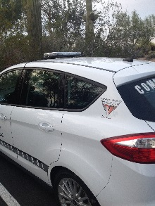Golf Cart for additional patrol

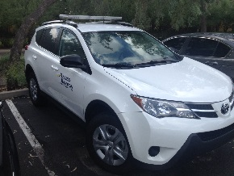

Figure : Current patrol vehicle

Figure : Example of logo and lights

Each vehicle will be customized very similar to current patrol vehicles with DC Ranch Association approval.

|  |  |
| --- | --- |
| Equipment | **Monthly Rate** |
| Toyota Prius (3) | $843 |
| Security Golf Cart | $264 |

**Pricing Summary Sheet**



****

## *Pricing Notes*

**Proposed Holidays**

AlliedBarton recognizes the following holidays:

* New Year’s Day
* Memorial Day
* Independence Day
* Labor Day
* Thanksgiving Day
* Christmas Day

All employees who work on a designated holiday will receive 1.5 times their wage rate for hours worked. AlliedBarton will invoice 1.5 times the hourly billing rate for hours worked on the designated holidays. Holiday revenue may or may not be included in our annual budget estimate or standard billing rates.

**Vacation**

Regular full-time hourly employees (security officers) will generally be eligible for paid vacation time based on their length of service (must average 35 hours per week to qualify). The standard vacation plan is accrued on a calendar year basis after reaching the first anniversary. Upon reaching the first anniversary, officers begin to accrue time and will be eligible for a pro-rated amount of vacation from their first anniversary date through the end of that calendar year. The following January, employees will be eligible for their full tier amount from 1/1 – 12/31. Tier Schedule: Paid vacation after one year of service (pro-rated); two weeks after three years and three weeks after eight years.

**Overtime**

Overtime of 1.5 times the hourly billing rate is only billed in the following circumstances and not for scheduling issues or vacation coverage.

**Proposed Short Notice Requests**

Requests with less than 72 hours notice will be billed overtime.

**Specific Requests**

With requests for a specific individual to work more than their 40 hours for a special reason, regardless of the notice provided, only the overtime impact for that individual will be billed. Example: “We need Officer Smith to stay two extra hours at the end of his shift to help with a special project.” Only the additional two hours will be billed at the overtime rate if it will put him over 40 hours.

**Requests for Officers That Exceed Five Percent of Total Deployment**

Requests for coverage in excess of five percent of the total officers’ base hours on site may be billed as overtime until coverage is incorporated into the permanent base hours.

**Payment Terms**

AlliedBarton will invoice the client on a weekly basis for all scheduled services for the preceding weekly period (starting on Friday and ending the following Thursday) based upon the rates listed above. All invoices are due net 30 days.   
  
**Rate Increases**

Billing rates will increase annually by 3% or by the percentage increase in certain agreed upon costs incurred by AlliedBarton, whichever is greater.  
  
AlliedBarton’s rates during the term will be subject to adjustment to reflect any increases in AlliedBarton’s costs related to medical, welfare and other benefits and related costs, which may include, without limitations, costs incurred by AlliedBarton pursuant to applicable federal, state and/or local law, including without limitation Health Care Reform Legislation Costs.



# Human Capital Management

*Recruiting*

Security officer quality begins even before we identify a candidate for a position with DC Ranch Association. In fact, AlliedBarton has developed a proprietary certification program that guides every step of our recruiting process. Our certified recruiters identify only top quality candidates. The talent pool is extensive, and it is the responsibility of our certified recruiters to narrow the field. Better recruiting translates into:

* Low turnover
* High-quality, screened candidates
* “Best-fit” personnel for your environment
* Consistent quality

**Certified Recruiters** - AlliedBarton’s recruiters are certified once they have successfully completed the Recruitment Community Basic Course. This curriculum focuses on quality versus quantity hiring, ensuring new hires meet our rigorous security officer standards, determining the right fit in client placement, meeting contractual requirements and improving employee retention.  
  
**Recruiting Resources**- The first step in the recruiting process is a thorough understanding of your site-specific needs. This enables us to pinpoint those requirements and recruit by position and post. We actively seek out candidates for security officers and managers based on stringent selection standards. Some of the recruitment resources we utilize include:

* AlliedBarton’s own recruiting website, jobs.alliedbarton.com
* Promotion from within and employee referrals
* Career websites (Career Builder.com, Employer Partnership for the Armed Forces, H2H and social networking sites such as LinkedIn, Twitter and Facebook)
* Civic organizations
* Colleges, Universities and Schools
* Former military in transition and reservists through our partnership with the Employer Support of the Guard and Reserve
* Job fairs and open houses
* Police and fire departments and rescue squads
* Professional networking with member organizations (ASIS, BOMA and ICSC)
* Senior associations
* Veterans administration and other veterans organizations

AlliedBarton has formed national strategic partnerships with the AARP, International Association of Jewish Vocational Services, National Indian Council on the Aging and National Asian Pacific Center on Aging to further the ability to recruit from multiple and diverse recruiting sources. These partnerships provide an additional network of high quality candidates for AlliedBarton recruiters who are committed to identifying the right security personnel for each customer.

***Hire Our HeroesSM -*** AlliedBarton Security Services is committed to hiring veterans, reservists, their families and caregivers, and promoting this important hiring practice. Our company-wide military hiring program, Hire Our Heroes, is an essential part of our recruiting strategy. The men and women who have dedicated themselves to serving our country make an incredible contribution in the workplace. AlliedBarton is proud to partner with military assistance programs to help put these heroes to work. Our nation’s military personnel are well-trained, responsible and dedicated to serving their country and their communities. Reservists and veterans possess the leadership qualities and skills needed to provide the high level of security services that our clients need and AlliedBarton demands. AlliedBarton has partnered with the following military assistance groups to ensure that our service men and women have opportunities as they transition back to civilian life:  
  
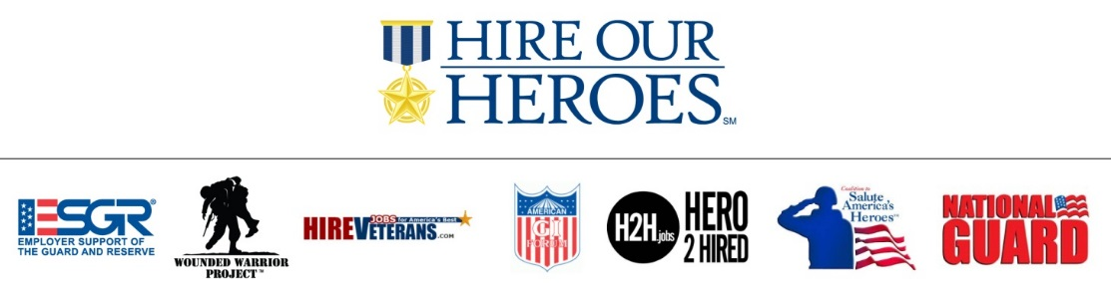

**Recruiting Process:** The vast number of recruiting resources we utilize along with our reputation for being a great place to work directly contributes to the more than one million candidates in our hiring pipeline. A large number of applicants means that we can select the right candidates for your security program. And, we have the resources to identify the most well-suited individuals quickly and efficiently.

To ensure high quality employees that are the right fit and have the right skills for your community, AlliedBarton uses an automated, highly customized Applicant Tracking System**,** AlliedBarton**|Gateway**SM. Our easy-to-use, digital platform features:

* **Advanced Filtering:** Utilizing a smart search feature, managers and recruiters are able to search for candidates by shift preferences, ranking, location and other requirements such as a driver’s license. This feature gives our recruiters an edge in identifying a qualified candidate quicker and allows us to meet your needs faster.
* **Paperless Processes:** Pre-employment forms can be completed and stored within AlliedBarton**|Gateway,** making the process paperless. Electronic signature capability allows for a smoother process and shortens the time from application to hire.
* **Transparency:** Candidates, recruiters and hiring managers can view the status of a position or application at any time during the process. This means that any questions you have about your open positions can be immediately addressed.
* **Integration:** Integration with other AlliedBarton systems such as background screening and drug testing, and our careers web site promotes efficiency; ensuring that every step in our extensive screening process is complete and only the best candidates are selected for your location.

One of the true differentiators in our recruiting process is the extra step that we take during the application stage. **In addition to completing our standard application information, candidates also answer questions related to their preferences for** **type of work environment.** These preferences correspond with profiles developed by an industrial psychologist, which allow for successful personnel to position matching.

The Guardian, Protector, Community and Concierge profiles are based on the level of people interaction, physical asset protection and safety awareness that each position requires. At AlliedBarton, we are not looking to fill a position with just any candidate. We go the extra mile to dig deeper to find the right person for you. When our employees are well matched to the position requirements, they stay longer in their position, will be better engaged in their day-to-day responsibilities, and provide better service for you. Our ultimate recruiting goal is to find the best qualified candidate for every post. This translates into improved security officer quality and better 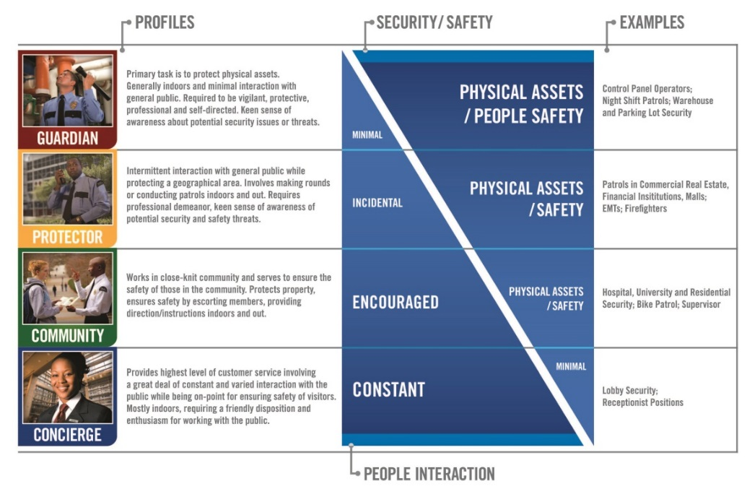results for DC Ranch Association.

**AlliedBarton only hires 5% of all applicants. Our proven recruitment process allows us to identify the security officers you need, when you need them.**

## *Screening*

Background screening is an essential component in our process for selecting high caliber employees for DC Ranch Association. Initial conversations with applicants provide an opportunity to evaluate demeanor, attitude and communications skills. Qualified candidates formally interview with our district recruiters and hiring managers. AlliedBarton’s standard screening process includes:

* Education verification
* Employment verification
* Criminal records check with stringent hiring standards
* Social Security check
* Electronic E-Verify and I-9 employment verification
* Motor Vehicle Report (for those officers designated to drive a vehicle)
* Five-panel drug test

**Application Review & Assessment -** Careful analysis focuses on employment history and stability. The application process includes a questionnaire utilized to assess writing skills and determine whether an applicant’s personal character is in-line with the company’s values.

**Interviews -** The initial in-person interview assesses punctuality and appearance and clarifies points of the candidate’s application. Multiple interviews may be conducted, and candidates progressing beyond this level will attend our orientation program.

**Education and Employment Verification (Reference Checks) -** AlliedBarton verifies high school diplomas or GED or highest degrees obtained, a minimum of one previous employer including military DD214 and current employer (after an offer is extended).

**Electronic I-9 and E-Verify -** Employment verification must be completed for all AlliedBarton employees to present proof of citizenship or authorized alien status. All potential employees are processed through E-Verify, the government’s employment eligibility system, as well.

**Management Testing -** Management testing may involve the Thomas Personal Profile Analysis, The Kenexa Manager assessment or The Kenexa Leadership assessment, depending on the position. These help assess candidates’ management abilities, drive, maturity and people skills, and evaluate whether they are a good fit.  
  
**Social Security Checks -** As an additional measure of precaution, we run Social Security checks on each candidate to verify identity and history of addresses. The latter is used to assure all associated addresses are considered when determining states and countries to be included in the criminal background check process.  
**Criminal Background Checks -** Prior to being hired, each employee undergoes a comprehensive criminal records check. Where required, fingerprints are taken and submitted to the appropriate law enforcement agency for a detailed background investigation. Statewide criminal checks are also conducted when required. AlliedBarton will only hire individuals who are suitable for employment in the positions for which they are being hired and who are eligible to hold a security guard license where required by state law.  
  
**Pre-employment Drug Testing -** All AlliedBarton candidates undergo a five-panel drug test prior to hire to screen, at minimum, for marijuana, cocaine, amphetamines, morphine and PCP. Preferred five-panel testing is either on-site urine or oral fluid (depending on state and contractual requirements). In states that do not allow on-site urine or oral fluid testing, we offer Intercept, an oral fluid device administered on-site with the results conducted by the lab. On-site ten-panel tests, off-site five-panel or ten-panel tests, hair follicle and alcohol testing are available at an additional charge.

**Motor Vehicle Report -** Officers designated to drive a vehicle are subject to Motor Vehicle Report checks and on-site training before they can operate a vehicle.

**Security Officer Integrity/Honesty Testing -** AlliedBarton offers the Reid Test for security officer integrity/honesty testing. This selection assessment tool evaluates attitudes and behaviors associated with high levels of integrity and productive work habits. AlliedBarton offers a discounted rate through a commercial arrangement.

## *Retention*

The elements of staffing stability are complex and interwoven, and include adequate wages and benefits, proper hiring, competent supervision, comprehensive training, employee recognition, opportunities for advancement and on-going performance evaluations. AlliedBarton is proud to have among the lowest turnover rates in the security services industry.

Many of our retention efforts are best illustrated through our incentive and recognition programs. Additionally, each of our management systems has elements designed to positively impact retention.

* Our screening process tests for an applicant’s predisposition to remain with an employer.
* Background checks show prior length of employment service.
* Our 30 day New Hire Survey checks with new hires to assure they have been onboarded to their satisfaction.
* Refresher training enhances and reinforces earlier learning.
* Our computerized scheduling system helps avoid assigning shifts that are too long and/or too close together.
* Regional HR Directors focus on employee relations, client satisfaction and compliance.
* Security Voice, our 24-hour security officer hotline, ensures an open line of communication and prompt attention to any officer need or question.
* Our management teams are trained and coached on human resource tactics that further promote employee retention.
* Decentralized management allows our senior staff to be actively involved with, and easily accessible to, our security officers.

A great retention program means security officers for DC Ranch Association are on board for the long term and are a reliable presence at your site. We have, in place, a database system that requires our recruiters to call each new hire around their 30th day of employment to ask a series of question designed to assure that they have had a smooth onboarding experience. This also allows for an open line of communication to resolve any issues related to their employment to assure continued employment.  
  
Our retention efforts also mean our management remains consistent. Several senior-level managers have dedicated their careers to AlliedBarton, starting as a security officer or management trainee. Now, years later, they are guiding our direction and growth, and your security program.

## *Turn-Over: Profit at Risk*

It is the goal of AlliedBarton to have zero turn-over of officers in a community. The overall strategy of, “taking care of the officers,” has helped AlliedBarton lead the industry in low turnover. AlliedBarton is confident that the turnover percentages will decrease as the Dare to be Great culture and our management processes are implemented into the security program at DC Ranch. AlliedBarton offers a “Profit at Risk” opportunity to help monitor and improve turn-over. The program works as follows:

If AlliedBarton attains the metrics below, we will either be awarded an incentive or will forfeit direct profit. This program risk approximately .5% of revenue each quarter. Turnover will be measured quarterly and paid quarterly on next billing cycle. (\*% based on 37 FTE). Please note that all turnover is measured. This program will not deter AlliedBarton from promoting officers, if their development and career path are justified, nor will it deter AlliedBarton from terminating an employee with just cause if needed to improve the security at DC Ranch.

|  |  |  |
| --- | --- | --- |
| Estimated Turn-Over % | **Estimated FTE** | **Incentive/(Penalty)** |
| 9% | 1 officer | $1,800 |
| 22% | 2 officers | $900 |
| 32% | 3 officers | $0 |
| 43% | 4+ officers | ($1,800) |

## *Benefits*

AlliedBarton has been a long-time industry leader in providing meaningful and affordable employee benefits. There is a direct correlation between providing employee benefits and attracting high-caliber personnel. Benefits are also a strong factor in employee engagement, which is critical to the success of your security program. Is your security team engaged? At AlliedBarton, we value employee engagement and strive to offer employee programs – including benefits – that keep our employees satisfied. In fact, more than 86% of our security officers say they would recommend or highly recommend AlliedBarton as a great place to work for friends or family members. That level of satisfaction is important to our success – and yours.

With the introduction of the Affordable Care Act, some security companies have dropped or plan to drop the affordable medical plans they once offered. Others that have historically not offered medical benefits to security officers are continuing on that path. AlliedBarton is taking a different approach. We know that healthcare benefits are extremely important to our employees, and that they prefer to have a choice when it comes to medical plans. We will continue to offer medical plans that are affordable and that best fit the needs of our security officers, while being fully compliant with the law. We are also advocates for our employees, providing healthy living tips and information to encourage them to become educated healthcare consumers.

When the ACA was first introduced in 2010, AlliedBarton formed a multi-disciplinary committee to address the issues and challenges presented by healthcare reform. That committee is still hard at work today, staying on top of changing healthcare regulations and ensuring that our employee and client needs are met. AlliedBarton’s long term strategy is to continue to offer healthcare benefits options that will attract the best personnel now and in the future.

Our employee benefits extend far beyond medical coverage. Dental plans, retirement savings and paid vacations are just some of the benefits available to our security officers. Employees who are offered benefits and fair compensation have peace of mind and a clearer focus on their daily job responsibilities. We also understand that when we take care of our employees, they take better care of you. Additional advantages include:

* Less absenteeism and turnover
* Improved performance results
* Assistance and resources for both personal and professional issues
* Convenient options for managing financial well-being
* Easy access to all benefit information through MyAlliedBarton.com, our employee website

Below are some of the benefits we offer our employees.

**Eligibility -** Beginning in 2015, but also including the prescribed look back period, AlliedBarton’s definition of full-time employment will be 30 hours per week for health and welfare benefits eligibility. AlliedBarton’s definition of full-time employment for vacation eligibility will remain at 35 hours per week.

**Medical Insurance -** AlliedBarton offers medical plans to all benefit-eligible employees through payroll deduction and/or client contribution. 2015 benefits will be offered pursuant to our eligibility requirements/policy. Detailed information regarding coverage and premium costs is available.

For 2015 and beyond, any estimated annual healthcare costs are subject to change. The estimates provided in this proposal are based upon proposed and evolving regulations, plan structure and estimated participation.

 

  

**Dental Insurance -** AlliedBarton offers quality dental insurance to all benefit-eligible employees through payroll deduction and/or client contribution.



 

**Vision Insurance -** AlliedBarton offers a Vision Service Plan to all benefit-eligible employees, which provides reduced rates for eye exams, glasses/contacts, etc.





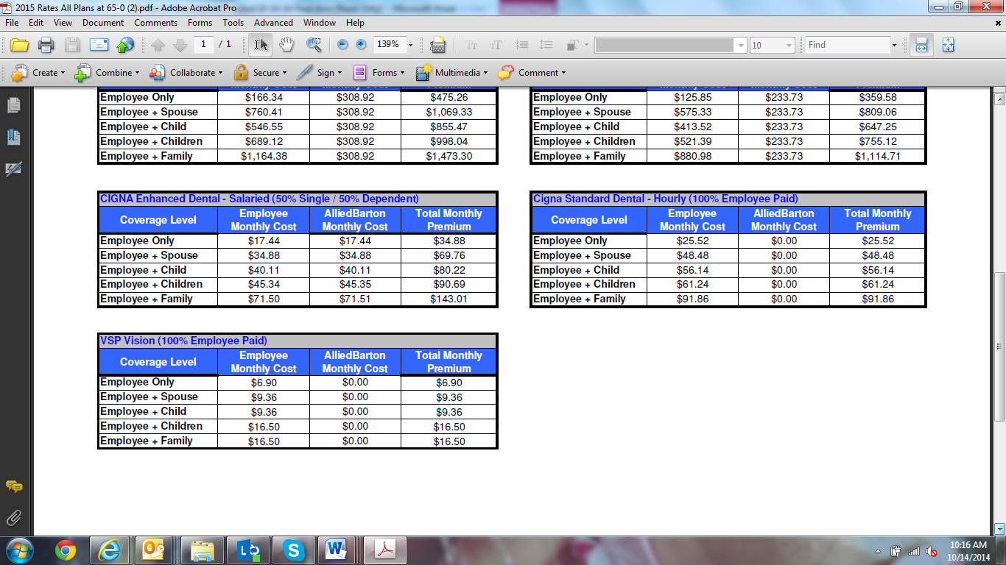

**Disability Insurance -** Benefit-eligible employees have the ability to participate in a Disability Insurance plan offered through Principal Financial Group.

**Life Insurance -** AlliedBarton offers Basic Life insurance in the amount of $10,000 to benefit-eligible employees at no charge. AlliedBarton employees with 15 years of service will be provided a minimum of $50,000 in Basic Life insurance at no cost to the employee. Additional supplemental life insurance and AD&D is available to employees at competitive rates.  
  
**Paycard -** Employees have the option to receive their pay through direct deposit or as a cash paycard (where permitted by state law). Similar to an ATM card, the paycard allows immediate access to wages without having to incur check cashing fees.

**Paid Vacation-** Security officers averaging 35 hours per week will generally be eligible for paid vacation time based on their length of service. The standard vacation plan is accrued on a calendar year basis after reaching the first anniversary. Upon reaching the first anniversary, security officers begin to accrue time and will be eligible for a pro-rated amount of vacation from their first anniversary date through the end of that calendar year. The following January, employees will be eligible for their full tier amount from 1/1 - 12/31. Tier Schedule: Paid vacation after one year of service (pro-rated); two weeks after three years and three weeks after eight years.

**401(k) -** AlliedBarton employees with at least six months of service are eligible to participate in our 401(k) retirement savings program with a company match up to 75%. Tier levels are as follows:

|  |  |
| --- | --- |
| 0-9 Years | 10% Match |
| 10-14 Years | 20% Match |
| 15-19 Years | 35% Match |
| 20-24 Years | 50% Match |
| 25+ Years | 75% Match |

**Holidays** - Security personnel receive time-and-a-half pay when working these holidays:

* New Year’s Day
* Memorial Day
* Independence Day
* Labor Day
* Thanksgiving
* Christmas Day

**Employee Assistance Program** - We offer work-related crisis management to employees.

**Legal Services**- Legal service is a benefit available to all employees.

**WorkPerks -** WorkPerks are fringe benefits available exclusively to our employees for personal use. They include discounts on fitness memberships, wholesale club memberships, cellular phone plans, retail merchandise, and hotels just to name a few. By partnering with these vendors, AlliedBarton employees can benefit from these special savings and offerings. Some of the recognizable names employees receive discounts with include: Hilton Hotels, Sprint, AT&T, Verizon Wireless, COSTCO Wholesale, DIRECTV, Dell Computers and H&R Block.

**Employee Recognition and Retention** **-** Quality that is rewarded is repeated. Formal recognition for exemplary service supports our culture of quality. Employee recognition also has a way of inspiring others to perform at a higher level.

At the heart of this effort is a sincere appreciation for hard work, good judgment and continuous improvement. All recognition is tied to our Security Officer Quality Standards as those are true measures of our success.

* **Security Officer of the Month -** Commemorative plaque and eligibility for Security Officer of the Year.
* **Security Officer of the Year -** Winner for each region with cash award.
* **Account Manager of the Year -** Winner for each region with cash award.
* **Support Person of the Year -** Winner for each region with cash award.
* **Dare to be GREAT Achievement Award Program -** AlliedBarton’s Dare to be GREAT Achievement Award program recognizes employees for actions that go above and beyond our already high standards of quality.
* **Length of Service Awards -** Various honors for every five years of service.
* **Personal and Professional Development -** AlliedBarton provides a myriad of resources for personal and professional development, including online courses via AlliedBartonEDGE.com, suggested reading lists, a library of other resources at district and corporate training offices, and personal support and coaching from supervisors.

# Security Operations

## *Supervision and Management*

Our local managers are empowered decision makers who understand the needs of your community. Managers help to develop AlliedBarton employees on a daily basis. They are the individuals who take the lead on program management and concern resolution to create a seamless security program. AlliedBarton has more than 50 years of security industry experience, including supporting a national network with human resources, training, recruiting, technology and strategic sourcing. We consider our local management teams to be a critical internal client, and we make their needs a priority. Our managers set high standards for service; standards that are maintained through continuous, effective supervision.

**Local Management Team**

* Michael Smidt, VP/GM Southwest: 28 years in industry, 10 year with AlliedBarton
* Jeff Meintel, Mesa District Manager: 20 years law enforcement, 7 years with AlliedBarton
* Shane Musgrove, Director of Client Value Managment: 17 years in industry
* Brian Lightle, Client Value Manager: 9 years military, 10 years international security
* Evan Drew, Mesa Field Operations Manager: 3 years military and 7 years in industry
* Damien Willis, District Trainer: 5 years with AlliedBarton
* Joleen Martin, District Recruiter: 3 years with AlliedBarton
* Brian Hampton, Business Development Manager

**Quality Inspections**

As a primary tool of the supervision process, inspections help us meet our contracted obligations. AlliedBarton inspects security services at client sites on a routine and random basis.

* Inspections offer the opportunity for management to work with security officers, providing hands-on training, mentoring and supervisory support.
* Officers demonstrate proficiency at their duties under close, expert observation.
* Ongoing inspections ensure officers consistently meet your expectations.
* Inspections provide positive reinforcement, solicit feedback and promote communications among supervisors and field personnel.
* Inspections allow us to identify any areas that need improvement or perhaps suggest changes in post orders that will result in better service.

**Account Manager Model**

AlliedBarton account managers represent the critical difference between AlliedBarton and other security providers. This manager is dedicated to your account, knows everything about your needs and the needs of our officers, and typically is rewarded through incentive compensation for performance in key functional areas.

**Post Orders**

To AlliedBarton, post orders represent the playbook that guides the day-to-day activities of the entire account security team. Post orders differ widely among contract security services firms. While some treat post orders as a little more than a telephone directory, AlliedBarton takes a far more serious approach. Post orders and Standard Operations Procedures Manuals are essential components of our security programs. Our local managers create, implement and update these manuals, while our security officers refer to them consistently. For your community, post orders will include all current service data and requirements, information we follow strictly and continuously.

**Incident Reporting**

Accurate incident reporting is essential in emergency situations, especially those cases that might involve police investigations or insurance companies. A regular review of incident reports from your community can also identify any security trends that may indicate a need for adjustments to your program. Our officers are trained in report writing to ensure accurate, detailed and clear information.

Each security officer will provide a report for any circumstances that require explanation, such as assistance of emergency units or notification of civil authority. Such incidents also include accidents, personal injuries and criminal activity. We maintain a file of incident reports on-site along with a summary report, if necessary.

AlliedBarton offers a web-based software package designed specifically to document security incidents. This helps streamline record keeping, produces clear and concise incident reports, summarizes incidents by selected criteria over specified time periods, and quickly retrieves past incident reports. We offer the software at a specially discounted rate.

## *Scheduling*

Accurate scheduling is a vital component of our effectiveness and client satisfaction. Our automated scheduling system provides DC Ranch Association with the most accurate, efficient scheduling available. The system not only plans who will work and when, it also integrates with our training compliance tracking to ensure scheduled security officers have the necessary training and skills.

In addition, our managers who are directly responsible for employee schedules participate in our How to Create and Manage a Schedule training program. This training helps ensure schedules are efficient and meet contractual requirements.

At AlliedBarton, we define quality scheduling as:

* Providing all hours of contracted service.
* Scheduling officers who have received every training specific to your site.
* Maintaining scheduling standards such as a maximum of 12 hours per shift, minimum of eight hours off between shifts and at least 24 consecutive hours off each week.

AlliedBarton’s scheduling system records the requirements of each post and allows for effective tracking of all changes. We can also quickly and appropriately respond to call offs due to illness or other events that could potentially disrupt fulfillment of coverage requirements.

AlliedBarton employees are given more than a week’s advance notice of their schedules so they can effectively manage their time and personal commitments without compromising their professional lives and service delivery.



# cid:./uploads/image/Christine%20Images/edge.jpgTraining

**Training for Success**

The AlliedBarton|**EDGE**® [**E**ducate, **D**evelop, **G**row and **E**ngage] is our proprietary learning and development program which includes our Learning Management System (LMS). This provides AlliedBarton employees with on-demand access, through *e*Learning, to modules that prepare them for future responsibilities and career opportunities. Our experience shows that virtually every measure of security officer quality can ultimately be tied back to the quality of our training program.

The AlliedBarton|**EDGE** goes beyond traditional training, providing enhanced course offerings, additional compliance functionality and more opportunities for employee growth. It is comprised of a nationwide network of more than 100 trainers; online, classroom and self-study training; a mentoring program; industry and client-specific and leadership training; as well as multiple other learning and development programs. For more information about the AlliedBarton|**EDGE,** go to [www.AlliedBartonEDGE.com](http://www.alliedbartonedge.com/).

Our compliance tracking capability through the AlliedBarton|**EDGE** allows trainers and managers to monitor and report training completion. Training that can enhance the quality of an individual or an entire team can easily be made available through online learning on the AlliedBarton|**EDGE**.

**Training Awards**

AlliedBarton Security Services is proud to have been named one of *Chief Learning Officer* magazine’s LearningElite top organizations for learning and development. We were recognized by peers and a benchmarking program for employing exemplary workforce development strategies that deliver significant business results. The LearningElite program utilizes best practices in evaluation to rank the best organizations based upon their impact, size and industries served.

We have also been named one of *Training* magazine’s Top 125 training companies, a list that includes Fortune 500 companies and leading businesses from many different industries. We are honored to have earned this designation for seven consecutive years, and to be the first security services company recognized by *Training* magazine.

AlliedBarton is also proud to have been honored with a Brandon Hall Silver Award for Excellence in Compliance Training. This prestigious award is recognition of our commitment to compliance in training and excellence in every aspect of our security programs. The Brandon Hall Award also honors our security teams who work hard for you every day. Following extensive research and a multi-tiered applications and interview processes, AlliedBarton was chosen for these awards based on our training programs, methods of employee evaluation and measurement, financial commitment to training, and the critical role training plays on our organizations success.

**eLearning**

Training compliance goes hand-in-hand with training availability and accessibility. Certain training courses are available in an *e*Learning format so security officers and managers can complete training at a time and place that’s most convenient. What’s more, eLearning makes training program management faster and more efficient, since it is unnecessary to coordinate multiple schedules.

Our interactive and easy-to-access LMS provides multiple platforms including but not limited to Safety, Emergency Preparedness, Mobile Patrol, Customer Service, Workplace Violence and the Leadership. AlliedBarton employees can log into the appropriate platform and complete a wide-range of training modules.

Scenario-based learning is a large component of our *e*Learning program and helps employees practice making decisions they need to make on the job. It stages a context where learners live and work their everyday life and is based on the idea that knowledge cannot be developed and fully understood independent of its environment. An employee is put in a situation and is exposed to issues, challenges and dilemmas and then asked to apply knowledge and practice their trained skills relevant to the situation. Through these mobile-accessible scenario-based courses, appropriate behavior to use when in a use of force situation is demonstrated and learned.

Lightning Lessons are another type of *e*Learning we offer our employees. Short bursts of learning for security officers are used as needed for refresher courses on topics such as fire safety, ethics and client experience.

**Additional Learning Platforms**

Some of the additional training methods include:

* **Podcasts:** Knowledge Knuggets, brief audio trainings, each about 1 minute 30 seconds, have been designed to provide safety and security information and to encourage our officers to take advantage of additional and more involved learning opportunities.
* **Video Library:** Various videos are available for further learning on several topics including job safety analysis, service animals and employee success stories.
* **Management Development:** Through instructor-led and virtual training, lessons are conducted on and off-site.

**Compliance Tracking**

Our compliance tracking capability through the AlliedBarton|**EDGE** allows trainers and managers to monitor training completion and accurately report progress. The AlliedBarton|**EDGE** continuously delivers training that enhances both individual and team quality.

Our commitment to compliance tracking extends beyond our training resources. WinTeam, AlliedBarton’s automated scheduling component, is the compliance module that captures training records for security officers. WinTeam works in conjunction with the AlliedBarton|**EDGE** and offers extensive compliance tracking and reporting functionality. Our managers access all systems through our secure intranet to support compliance verification. These programs work together to enable trainers and managers to track employee progress through initial, specialty and refresher training, and to easily verify compliance.

Your security program requires not just an ongoing commitment to training but an assurance that training is completed to specification at all times. Every member of your security team needs up-to-date training to properly perform their duties and be engaged at a level where your safety and security is their top priority. AlliedBarton understands this need and has made a commitment to learning and development, and excellence in compliance, which is unsurpassed in our industry.

## *MSO Level I - Essentials Orientation*

Essentials Orientation prepares our security officers to be ready for Practical Application training when they arrive at DC Ranch Association. MSO Level I Essentials Orientation, where officers learn the fundamentals of their responsibilities, is normally delivered as an instructor-led classroom course and is also available online at our district offices. The curriculum includes:

* Welcome to AlliedBarton
* Dare to be Safe
* Legal Powers and Limitations
* Employee Relations
* Client Experience

All topics are tested for comprehension during the final exam, and employees must pass with a grade of at least 80%.

Upon graduation from MSO Level I Essentials Orientation, each security officer receives:

* An AlliedBarton security officer employee handbook
* A briefing on their upcoming MSO Level I Practical Application Training for site-specific skills
* A briefing - and encouragement - on AlliedBarton’s continuing education and professional development programs

## *MSO Level I - Practical Application*

Practical Application occurs on site, is site-specific and customized according to the complexity of your community. The Practical Application Checklist is completed and entered into our online employee database providing a checkpoint for this important phase of officer training.

AlliedBarton professionals who understand your specific requirements train officers at your facility. The Checklist and Workbook consist of a wide range of topics including:

* Access Control
* Bomb Threats
* Electrical Emergencies
* Emergency Contacts
* Equipment Removal Procedures
* Fire Alarm Response
* ID Checks
* Key Control
* Mechanical Emergencies
* Media Relations
* Medical Emergencies
* Opening and Closing Procedures
* Parking and Enforcement
* Parking Lot Security
* Patrol Techniques
* Post Responsibilities
* Report Writing
* Terrorism Awareness
* Use of Telephones
* Vehicle Assistance
* Water Leaks
* Weather Emergencies

A security presence is important, but a motivated, directed security presence with a purpose, assignment and goals is effective and critical to your organization. MSO Practical Application training and post orders will define the role of your security officers and guide your security program.

*School of Residential Security: Training Curriculum*To ensure that our AlliedBarton Residential security officers have the best knowledge base to serve our clients, we have created a specialized curriculum that meets the unique security and safety requirements of this industry. Knowledge and skill-based testing and evaluation are incorporated throughout this program. The Residential Security curriculum is divided into two levels and can commence upon successful completion of Master Security Officer Level I Essentials Orientation and Practical Application. The course content is as follows:  
  
**Residential Security Basics** - This course is designed to give new residential community officers a basic understanding of the challenges related to providing security in residential and gated communities. Topics include:

* Basics of residential community organizations
* The importance and necessity of strict access control procedures
* Common security threats in residential communities

**Customer Service** - Our Customer Service training is designed to ensure that our officers provide outstanding assistance to both internal and external clients. Topics include:

* How to identify your internal and external clients and their expectations
* The importance of "perception" and "presentation"
* Telephone skills
* Tips for delighting clients
* How to effectively handle client complaints
* Resolving conflicts

**Special Residential Populations** - It is imperative that our officers understand the special needs and challenges of not only dealing with older residents, but with youth as well. Topics covered include specific age-related injuries, safety issues and crime statistics targeted to this group.  
  
**Practical Application On Site Training** - Practical Applications training program consists of an extensive checklist of general policies and procedures all officers must know to be successful at their worksite. This training is conducted in conjunction with the Practical Application Workbook, a manual that provides instruction for both new employees and facilitators on how to execute this training.  
  
This program contains a variety of site-specific training topics, including:

* AlliedBarton Security’s General Orders
* Post Orders
* Access Control Procedures at the Worksite
* Customer’s and AlliedBarton’s Chain of Command
* Emergency Phone Numbers
* Medical Emergency Procedures at the Worksite
* Fire Emergency Procedures at the Worksite
* Patrol Routes and Procedures
* Bomb Threat Procedures
* How to Use Site-Specific and Special Equipment
* Safety Orientation Procedures
* Customer Service at the Worksite
* Handling Hostility and Crisis Intervention

**Access Control** - This course covers all aspects of access control within a gatehouse and incorporates emergency procedures.

* Electronic
* Manual
* Power outages
* Processing
* Paper documentation
* Quick reference sheets
* Denying visitors
* Consistent application

**Effective Patrolling Techniques** - Since many residential communities are decentralized environments comprised of several buildings, it is important that our officers know how to effectively and efficiently patrol. This section covers tips and techniques for conducting thorough and comprehensive patrols.

* Domestic violence
* Resolving conflicts
* Static patrols
* Foot patrols
* Vehicle patrols
* Using senses

**Traffic Control** - This training covers the different types of traffic control that our officers may be faced with. Officers are also trained to help identify any issues and maintain safety procedures.

* Radar
* Public or private
* Special events
* Ticketing/violations
* Use of vehicle

**Alarm Response** - This training teaches how to effectively and safely respond to alarm response within a community.

* What to and not to do
* Legal issues
* Response times
* Proper documentation
* Team response (multiple patrols)

**Tactical** - This training covers more advanced types of patrol responses.

* K9
* SRT

**Bike Patrol** - Covers the benefits and limitations of this type of patrol. Gives overview of how this patrol can enhance the effectiveness of the security team.

* Community exposure
* Enhanced access to out of the way locations
* Uniform
* Equipment

**EMS Service** - AlliedBarton offers the standard two year American Heart Association CPR, First Aid and AED certification training **(2 free CPR/AED ½ day courses classes for DC Ranch)**. This training is either conducted by a local or regional AlliedBarton trainer, or is outsourced through the community. Also available are advanced EMS services for the community with the need and budget to warrant these types of services.

* CPR, laminated hand-outs
* First responder: infant, child and adult CPR, basic first aid, AED laminated hand-outs
* BLS programs: Basic Life Support, enhanced first responder program provided by trained and licensed EMTs. Overseen by a Medical Director capable of providing Oxygen support and EPI Pen, as well as more advanced first aid.
* ALS program: Advanced Life Support, the most advanced level of EMS available.  This program provides all of the services by Local Fire rescue with the exception of transportation to the hospital. Provided by trained and licensed EMT/Paramedic, overseen by a Medical Director with a full complement of medical equipment such as narcotics and medications, full defibrillator and a wide assortment of other specialized equipment.

**Emergency Preparedness** - This training was designed to give security officers the basic knowledge necessary to effectively manage most emergency situations. The curriculum covers a wide variety of important topics, including:

* Terrorism
* Natural disasters
* Communication or lack of
* Recovery
* Emotional reactions to disasters
* Evacuation procedures
* Communicating evacuation orders
* Maintaining evacuation routes
* Accommodating occupants with special needs
* Specific emergency considerations
* Hazmat
* Crime scenes
* Homeland Security
* Laminated cheat sheet hand-outs

**Report Writing** - This training covers the importance of proper report writing. Including the six key points in any report - who, what, when, where, why and how.

* When to write a report
* When in doubt, write it out
* Quotes and statements
* What to include
* Distribution
* Follow up

**Communication** - This training covers the proper use of radios and cell phones. Includes advanced concepts of verbal communication to provide the most effective communication.

* Call signs
* 10 codes and signal codes
* Specialized codes, fire rescue, law enforcement, etc.
* Incorporating the client, maintenance, grounds personnel
* Patrol and gate communication
* Dispatch
* Radio checks
* Maintenance of equipment
* Explanation direction for use of a repeater or air time
* Laminated cheat sheets, quick reference cards

**Vehicle Use, Maintenance and Care** - This course covers all aspects of vehicle usage.

* Vehicle checklist
* Automobile
* Golf cart
* Bike
* Daily maintenance
* Servicing vehicles
* Vehicles out of commission
* Safe driving
* Proper parking
* Passengers

**Dedicated Training Personnel** - This course provides training of on-site trainers within the staff. This leads to consistent training of all personnel. In most cases this will be a ranked officer or Site Supervisor who has shown an understanding of procedures and an ability to lead by example.

* Access control
* Patrol

**Community Facilities** - This course covers the specifics necessary for officers who work in environments where there are pools, large clubhouses, golf courses or tennis courts. Gives a general overview of what they may be faced with. Awareness of different types of emergencies, rules and regulations, etiquette, functions and client staff.

* Golf
* Tennis
* Pools
* Fitness
* Restaurants
* Shops
* Member Services

**Compliance Officers** - This course covers all aspects of what a Compliance Officer may be required to perform. This is a relatively new offering where the officer assists the property management in community rules and restrictions. Not to police, rather to assist residents in their compliance to help expedite proper community related rules and regulations. Related topics include:

* ARBs
* Documentation
* Community rules
* Customer service
* Violations
* Landscaping
* Mailboxes
* Additions

## *Driver Training Course*

Driver Training is a two-part, four-hour course designed for AlliedBarton employees who will drive a vehicle while on duty. This applies to both AlliedBarton and client-owned vehicles. The Driver Training Course is conducted by an AlliedBarton trainer, and is also available online. Each student receives a booklet containing all the presentation materials and sample forms. Among the topics covered in the course are:

* ******AlliedBarton’s Driver/Vehicle Policy
* AlliedBarton’s Rules on Vehicle Operations
* Patrol Driving
* Video: Safe Driving for Security Officers
* Accident Reporting
* Vehicle Inspection Checklist
* Vehicle Trip Log
* Supervisor’s Vehicle Accident Investigation Report
* Vehicle OJT Checklist
* Golf Cart Operation
* Daily Golf Cart Inspection Report
* Road Test for Golf Cart Operations

The second part of the Driver Training Course occurs at the worksite, with the actual patrol vehicle. The Vehicle OJT checklist guides the student and the trainer through the safe operation of the patrol vehicle, using the actual patrol routes.

## *Master Security Officer*

Our Master Security Officer program provides training and opportunity for, and encourages, personal and professional growth. There are five levels within the MSO curriculum. The first level is mandatory and designed to successfully onboard new employees into AlliedBarton’s culture, the security profession and the unique requirements of the job site. MSO Level I must be completed prior to assignment. MSO levels II through V are voluntary. This comprehensive education program consists of 30 courses covering various topics important to AlliedBarton, our clients and the security industry. Upon completion, employees achieve the coveted AlliedBarton Master Security Officer designation.

|  |  |  |  |  |  |
| --- | --- | --- | --- | --- | --- |
| **MSO Level I Essentials Orientation** | **MSO Level I Practical Application** | **MSO Level II** | **MSO Level III** | **MSO Level IV** | **MSO Level V** |
| * Welcome to AlliedBarton * Dare to be SAFE * Legal Powers and Limitations * Employee Relations * Client Experience | * Report Writing * Access Control * Patrol Techniques * Terrorism Awareness * Practical Application Checklist | * Fire Safety Officer * Physical Security & Loss Prevention * Patrol * Crime Prevention & Response * Workplace Safety | * Advanced Report Writing * Preventing Workplace Violence * Emergency Situations * Dealing with Aggressive Behavior * Ready Response | * Customer Intimacy * Time Management * Basic Investigations * Cultural Diversity * Strikes, Pickets & Crowd Control | * Interpersonal Communications * Managing Conflict * Interviewing Witnesses and Suspects * Teamwork * Principles of Leadership |

## *Specialized Training Tools*

If DC Ranch Association has a specific need, we can meet it with appropriately trained officers. We believe every security program is unique, so the training for your community must be as well. Our comprehensive training courses cover a wide range of markets and topics and are also available in multiple formats. AlliedBarton’s training is award-winning and that is demonstrated every day by the quality of our officers.

**Fire Safety Officer Training -** AlliedBarton’s Fire Safety Officer training includes the following components of fire safety:

* Detecting and preventing fires
* Reacting to fires
* Fire extinguishers
* Avoiding injuries
* Hazardous materials

**Specialized Service Offering Training -** AlliedBarton offers specialized training programs for security officers serving the following industries: healthcare, commercial real estate, higher education, residential, manufacturing/industrial, chemical/petrochemical, financial institutions, shopping centers and malls and government services. Each market has unique and individual security challenges that should be addressed with specific training. Our blended-learning approach features a comprehensive, industry-specific training manual, AlliedBarton’s FSO course, CPR/AED/First Aid (as applicable) and a final exam.

**Safety Officer Specialist Training -** AlliedBarton employees who successfully complete this voluntary program are designated Safety Officers. Courses covered in this self-study program and final exam include:

* Injury & Illness Prevention
* First Aid, Incident Reporting and Investigation
* Job Safety Analysis
* Workplace Violence
* Emergency Action/Fire Prevention

Safety Officer Specialists can champion safety initiatives at our client sites, help ensure a safety conscious work environment and are proud to play an active role in your safety program.

## *Supervisor’s Workshop*

Our Supervisor’s Workshop readies our supervisors for their management roles and helps them engage our officers so that they can effectively meet your needs.

The Supervisor’s Workshop is designed to help prepare first-time site or shift supervisors and managers for the challenges of leadership. This workshop consists of one full day of classroom, instructor-led training and must be completed within a supervisor’s first 60 days on the job, and as a refresher every three years. Curriculum includes:

* Introduction to AlliedBarton Security Services
* Role of the Supervisor
* AlliedBarton’s Training Process
* Employee Relations for Supervisors
* Report Writing for Supervisors
* Coaching and Counseling
* Progressive and Attendance Discipline

## *Operations University*

Well-trained and experienced managers are instrumental to a security program’s success. DC Ranch Association needs effective decision makers, and our managers are trained and molded to help make your account run smoothly.

Operations University is an intensive, interactive three-day classroom workshop for AlliedBarton Account Managers and District Managers with the goal of shaping proficient managers with a smart business sense. The class is conducted by seasoned executives and training managers to pass along real-life experiences in the process. The workshop focuses on a variety of business and security-related topics. New managers generally attend Operations University within their first two months with AlliedBarton.

The Operations University curriculum includes:

* AlliedBarton Business Overview
* AlliedBarton’s Training Programs & Processes
* Finance 101
* Employee Benefits and HR Procedures
* Payroll Procedures and Best Practices
* Invoicing Procedures and Best Practices
* Customer Relations Management
* Recruiting and Retention
* Employee Relations and EEO
* Coaching and Counseling
* Progressive and Attendance Discipline

## *Security Academy in Leadership*

AlliedBarton leaders often credit part of their success to the assistance and coaching of other managers who helped them grow. Security Academy in Leadership (SAIL) formalizes that guidance and strengthens the relationships between our employees. This provides DC Ranch Association with high-quality managers who can best serve your account.

SAIL is a tool to support our management teams in successfully facilitating mentoring relationships. The program augments employee development and performance, and helps managers thrive through partnerships with our senior-level leaders.

Engaging our managers through these types of relationships allows them to develop management skills, embrace the AlliedBarton culture, establish rewarding careers and better serve our clients’ needs.

*Performance Management*

We are committed to providing tools and training to help our managers engage, manage and retain our most important asset - our employees. For DC Ranch Association, the result is simple, yet profoundly important - motivated and engaged managers who perform at their best and continue to grow professionally and personally.

Performance evaluations, development and goal planning are all part of our Human Capital Management programs.

Our Performance Review process ensures all employees have the opportunity to receive a formal review and feedback on performance. This comprehensive review process benefits the individual employee, the entire organization and ultimately, our clients.

AlliedBarton|**Path**®, our performance management software helps our managers effectively evaluate performance - their own as well as their employees’. The program includes online evaluation forms, goal planning and in-person meetings.

Our performance management program is linked to the AlliedBarton|**EDGE**®. By coupling performance management with our comprehensive approach to learning and development, managers can recommend training that will help employees reach their goals.

## *Dare to be Safe!*

Safety and security go hand-in-hand, so it’s important that your 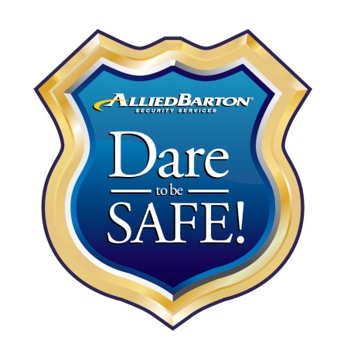security program reflect the same. At AlliedBarton, our commitment to maintaining a secure working environment begins with a national support network, and reaches our more than 60,000 security officers and our more than 120 offices. Our clients appreciate our commitment to safety and our security officer’s dedication to keeping your residents safe.

AlliedBarton’s culture of safety is embodied in Dare to be Safe! This program instills a personal commitment to safety in every one of our employees. The program has resulted in fewer accidents, less time lost from work due to injury, and fewer service interruptions for our clients.

Dare to be Safe! is driven by AlliedBarton’s national and regional safety committees, which create educational tools to help maintain a constant focus on safety. The national committee meets quarterly, and includes Division Presidents and the Director of Risk Management, department representatives, along with our safety and risk consultants. These committees identify and implement safety programs and educate employees at all levels.

The safety committee creates the tools to educate employees about safety. These include:

* A safety manual outlining AlliedBarton’s safety-related policies and procedures.
* A tool kit containing pertinent safety information.
* A safety calendar featuring a different theme each month. Topics include Slips, Trips & Falls, Accident Investigation, Fire Safety, Vehicle and Transportation Safety, etc.
* Monthly tips and articles related to the safety theme of the month that appear in the company newsletter and can be included in post orders.
* Our Dare to be Safe! committee and training leaders developed our Safety Officer Specialist training program. Employees who successfully complete this training are designated as Safety Officers.
* Posters at each district office as a reminder that safety is everyone’s responsibility.

Dare to be Safe! dry-erase boards are available to job sites to record and publicly acknowledge the number of accident-free days worked.

# Quality Assurance for DC Ranch

AlliedBarton strives to p*rovide the highest quality security personnel and service to every client*. Our quality assurance efforts are proactive and ongoing. We want to ensure every security program exceeds our clients’, and our own, high expectations. Our desire to identify opportunities for improvement and share best practices helps us keep our programs fresh and our service offerings geared to our clients’ unique needs. All security programs, whether they’ve been in place for 10 months or 10 years, are carefully reviewed and monitored to ensure contractual obligations are met and your program is efficient and successful.

We are faced with unrelenting changes in our industry; these challenges come from government, employees and our clients. To meet these challenges AlliedBarton has adopted the continuous improvement process of total quality management.

**A Team Approach to Quality Assurance**

At AlliedBarton, we recognize that most quality improvements take place in our organization through teamwork.

* Senior management works together to develop and implement plans for AlliedBarton’s future.
* We use cross-functional groups for special quality-improvement initiatives.
* Our district staff functions as a team, working toward the common objective of providing service that delights our clients.
* We operate as empowered work teams at our client sites.
* We implement quality action teams for special projects at all levels of the organization.
* Our internal teams work together with our clients to conduct Quality Business Reviews to be sure we are providing the best possible security services and to identify any new needs or areas in need of improvement.

**Quality Business Review**

We conduct regularly scheduled meetings between the DC Ranch Association security management team and AlliedBarton local management. In these meetings, we assess performance, report issues, and identify areas that can be improved. These reviews are designed to reflect on what we have accomplished together and to benchmark and establish measurable goals.

## *Performance Measurements*

We offer the best security program available. But there is room for improvement in every organization. In order to provide you and your residents with the best possible service, we regularly review and measure our performance.

To ensure quality service and identify opportunities for further improvement, AlliedBarton critically assesses our performance by measuring the following key areas:

* Weekly service hours – OT, billed OT, billed hours
* Employee retention
* Employee tenure
* Recognition and rewards
* Training
* Incidents
* Performance evaluations
* Trends
* Customer satisfaction survey results
* Best practices
* Accomplishments
* Goals and improvement processes

Additionally, we can tailor the above measurement processes to meet your specific key performance indicators.

*Internal Quality Audit*

Security programs must be reviewed regularly to be sure we are meeting the ever-changing needs of our clients. AlliedBarton’s new initiatives and enhanced training programs are the results of our internal quality audits. We continuously review our services and programs to ensure we exceed the expectations of DC Ranch Association.

* **Account Audits -** AlliedBarton conducts an annual audit for each account. The audit covers contract compliance, staffing levels and officer deployment, review of post orders and procedures, training, documentation, wage review and billing consistency.
* **Account Standards -** All AlliedBarton accounts must comply with account standards mutually agreed upon between the client and AlliedBarton management.
* **Performance Evaluations -** Hourly personnel and management staff receive formal performance evaluations every year. All evaluations are tracked in our integrated human resources system.
* **Management Inspections -** The local AlliedBarton management team is committed to regular, nonscheduled inspections at each client location. Management uses these inspections to promote consistent service delivery.
* **Client Surveys -** In addition to our standard AlliedBarton|**Voice** surveys, we can also work with your management team to survey your employees regarding security officer performance.
* **On Site Focus Groups -** We schedule focus groups with our officers, and where applicable, members of your staff to discuss ideas on process improvements.
* **The AlliedBarton Problem Solving Process -** We use this process to define existing and potential problems, analyze the root cause, and then implement solutions and quality controls.

*AlliedBarton|****Voice****SM*  
To help ensure DC Ranch Association’s ongoing satisfaction, and to be responsive to your evolving security needs, AlliedBarton is committed to continuous improvement based on your feedback. AlliedBarton|**Voice** is our formal voice of the customer program that proactively enhances communication and measures customer satisfaction. Through this program we listen to the needs of 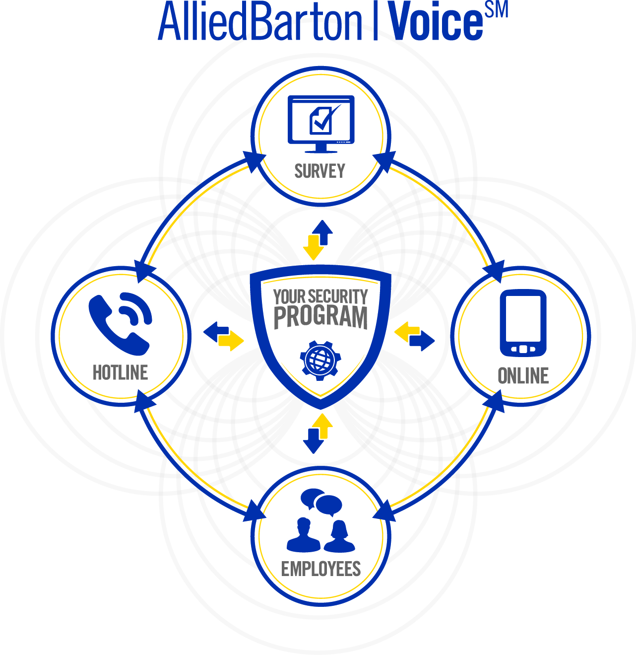our clients and employees, and act upon your feedback in a timely manner.

While local management will serve as your primary contact, additional communication tools are available during and after normal business hours including an AlliedBarton|**Voice** toll-free hotline, email and an online form (also accessible from mobile devices), all devoted exclusively to client communication.

Your inquiries are logged into the AlliedBarton|**Voice** database. Each issue or question is assigned an individual case number; and all cases will be monitored to ensure action plans are developed and executed in a timely fashion. To ensure results are delivered to your satisfaction, every case is tracked electronically until resolved.

**Online Survey Process**

Tracking DC Ranch Association’s experience throughout our relationship and earning your loyalty is the key objective of AlliedBarton|**Voice**. By requesting and measuring feedback through client and employee surveys, AlliedBarton can develop and deliver a superior security experience and continuously evolve to meet your needs.

* **New Client Survey** –We begin soliciting your feedback right from the start. We want to know why you selected us and your initial thoughts on our service offerings.
* **Transition Assessment** – Meeting or exceeding your expectations for a smooth transition is our goal. Three months after we commence service, we will request feedback on your satisfaction with the transition.
* **Annual Relationship Survey** – Measuring your ongoing satisfaction is critical. Net Promoter Score (NPS) methodology will be utilized annually to ask how likely you are to recommend AlliedBarton to a friend or colleague. Your loyalty is our goal because we want you to have a high quality security program now and into the future. This is an important component of ensuring security is an integral part of your business. NPS methodology is a globally recognized, innovative approach that a many Fortune 500 companies utilize today. NPS is distinguished from other surveys through its measurement of how clients’ feel about the total organization, and through our executives engagement in understanding the specific actions needed to maintain and improve client satisfaction. Your feedback helps guide our company-wide initiatives and enhances our local response.
* **Employee Survey** – Feedback from the security personnel at your site regarding their satisfaction is critically important. Security officers that are engaged and committed will provide a better security program for you.

We recognize that to truly be a partner, formal feedback is extremely valuable. All employee and client feedback is stored centrally to allow for careful monitoring and trending of service expectations, providing tangible data for continuous improvements. AlliedBarton|**Voice** is another world-class program that exists to support your needs and help you meet your security goals.

## cid:./uploads/image/Christine%20Images/Service%20Assurance%20Centers.png*AlliedBarton|******Support Center*****

Our local offices will serve as your primary point of contact. However, the AlliedBarton|**Support Center** is available to assist DC Ranch Association after hours, and for special emergency needs.

AlliedBarton|**Support Center** Advantages:

* Operates round-the-clock, 365 days a year.
* District office calls are forwarded to the AlliedBarton|**Support Center** at the close of each business day.
* The AlliedBarton|**Support Center** dispatches calls and messages immediately to the appropriate manager, whether by home phone, pager or cell phone.

## *Net Promoter Survey*

At AlliedBarton, our goal is to deliver the best security services tailored to your individual needs. To ensure your ongoing satisfaction, and to be responsive to your evolving needs, we are committed to continuous improvement based on your feedback.  
  
AlliedBarton is the first in our industry to adopt the Net Promoter methodology for measuring client loyalty. This survey asks how likely our clients are to recommend AlliedBarton to a friend or colleague. Client loyalty is a true measure of business success. Our clients’ satisfaction is not enough. We strive to develop collaborative partnerships that our clients value as an integral part of their business. That is what creates client loyalty, and what we will strive to create for you.    
  
This survey methodology is a globally recognized and innovative approach, with eight years of research behind the process. The key points that distinguish this program from other surveys are that it measures how clients feel about the total organization, and that our executives engage in understanding the specific actions needed to maintain and improve client loyalty. Your feedback guides our company-wide initiatives and enhances our local response. As a security provider that is truly in touch with your needs and provides solutions, we can help you reach your security goals.  
  
We recognize that to truly be a partner, formal feedback through surveys is extremely valuable. And once we’ve gathered that feedback, we quickly put into action continuous improvement initiatives to meet your needs.  
  
This program represents another first in AlliedBarton’s drive to be the most responsive security services partner for our clients.



# Technology

**Our proposed program includes integrated services as well as technology and equipment that will make your security team more effective in their job and enhance safety, security and customer service.**

AlliedBarton continuously reviews exciting new technologies to learn how they might enhance security and improve customer service. From scheduling, payroll and invoicing processes, to communication and documentation, AlliedBarton employs technology to gain efficiencies, ensure accuracy and enhance turnaround. The result is more efficient, streamlined business processes, smoother operations and greater value.

AlliedBarton’s more than 120 offices nationwide are all connected to our fully integrated business systems and supported by our dedicated Information Technology department.

AlliedBarton’s commitment to meeting the needs of DC Ranch Association through technology solutions includes the following business offerings:

* Automated Schedules and Invoices
* Electronic Invoicing Capability
* *e*Learning
* Compliance Tracking
* Business Continuity
* Security Incident Management
* Guard Tour Management
* Tour Verification/Compliance
* Dispatching Systems
* Electronic Procedures
* Visitor Management
* Access Control
* CCTV/Video Surveillance
* Mass Notifications
* Situational Awareness
* Risk Assessment & Analysis
* GPS Tracking
* IT Security

## 

## *Business Continuity*

AlliedBarton’s core systems are hosted in a secure data center at SunGard in Philadelphia, PA, with multiple layers of redundancy. Our applications are deployed over a wide area network to more than 120 offices throughout the U.S. Our company has taken steps to ensure system integrity, including both physical security measures as well as mission-critical system security practices.

Remote access to email and our intranet allows our management and support staff to operate from anywhere. Our focus on local management also ensures that business will continue as usual if there is an unexpected challenge. We have the resources in place to fill open positions, provide additional staff and management as needed. AlliedBarton can meet the security services needs of DC Ranch Association at all times.

access*AlliedBartonSM*

accessAlliedBartonSM, AlliedBarton’s secure client website, creates seamless collaboration and information sharing to help increase productivity for you and enhance compliance. This convenient system is available to AlliedBarton clients at no charge and offers many benefits. It is the total security solution for:

**Instant Account Access:** All of the information you need is at your fingertips! There is no waiting for information with *access*AlliedBarton. Reviewing your account information is simple and can be done through a mobile application on your smartphone or on a computer. The process is as easy as online shopping or online banking information. Hundreds of AlliedBarton clients at more than 2,000 service locations utilize *access*AlliedBarton.

**Invoicing Made Easy:** With *access*AlliedBarton, you always know your payment status and can view past invoices for the last 18 months.

* Review invoices whenever you need them
* Print, save or export invoices in whatever format you prefer
* View billing and payment information by time and location
* Quick access to past data for security program planning and budgeting
* A sustainable solution – save paper and reduce waste

**Ordering Made Easy:** Using the online ordering feature, you can request temporary or additional security coverage at any time of day.

* Receive order confirmations and see order status
* Your AlliedBarton manager is automatically notified

**Personnel Scheduling Made Easy:** *access*AlliedBarton allows you to view regular posts, extra and scheduled coverage, and export and print schedules.

* Gain real-time knowledge of which security officers are on-site or who is scheduled for your facility
* See you coverage levels at any time
* Review turnover and compliance information as well as employee rosters

**Quality Assurance:** Using the Quality Assurance module, you can monitor security inspections and other quality assurance items.

* Sort and search for specific security inspections in real time
* View photos, notes and quality scores within each inspection

**Compliance:** Training records can be tracked in real-time through *access*AlliedBarton to ensure that security officers are trained appropriately for your location and in compliance with your needs.

*access*AlliedBarton is also a great communication tool for our employees. When they have the information they need, they can be 100% focused on your security. Security officers and managers can log into the secure, online site to:

* Review schedules
* Update personal contact information
* Read job/site specific information
* Access pay stubs
* View pay stubs and schedules on smartphones with the eHub app

The availability of on-demand access to business information and reporting such as scheduling information, confirmation of changes or requests, training records, inspections, invoices and payment history that match your preferences means that you can spend more time focusing on your core business.

# Uniforms

The security officers at your site are representatives of your brand. Not only does their look help convey their authority and role, but how they present themselves must equate to their position as a leader. If an employee or visitor assumes a contracted security officer is a DC Ranch Association employee, will you be proud of the association?

The distinctive AlliedBarton uniform is easily recognized as superior in the security industry. It is intentionally designed to accomplish several critical goals:

* A professional appearance
* Security officer comfort and safety
* Durability
* Extra breathability
* Easy care/low maintenance for the security officer
* Fashionable style and proper fit

The construction and design of a uniform matter. Your security officers are active and their uniforms should be designed for both image and functionality. AlliedBarton has invested in quality uniforms that allow security officers to feel confident and look professional while performing their duties. This investment is just another example of AlliedBarton’s focus on the programs, processes and systems that support our most important asset – our people.

Extra care has been taken to address both form and function, including:

* Properly hemmed pants
* Shirts with zip fronts concealed under buttons
* Extra stitching and fabric for enhanced durability
* Soil resistant fabrics
* Triple strength pocketing

*The Right Look for Your Environment*Your uniformed security professional should harmonize with the requirements of his or her position. A neatly uniformed, well-groomed security officer commands respect and authority and helps to project a professional image for DC Ranch Association.

A security team who understands the importance of a neat and professional appearance and sets the highest industry standards for uniforms, accessories and personal grooming requirements will benefit your security program. The security officer is the first person your resident`s come in contact with. They are a direct reflection of your company and an ambassador of your brand. That is why it is important to select security officers who take pride in their appearance each and every day.

**Our Assurance**

AlliedBarton’s program for uniform and appearance starts when the security officer is hired. What differentiates our uniform and appearance program is the attention to detail and commitment to ensuring a professional look at your location. This three-step process includes:

* Personnel who issue uniforms are trained to measure for proper fit
* Security officers are trained and provided tips on how to wear the uniform properly
* Inspection programs ensure that security officers are dressed correctly and when uniform pieces need replacement, action is taken in a timely manner

**Grooming**

Personal grooming and hygiene are every bit as important as the proper uniform. Each security officer understands the importance of his or her position, the need for a positive attitude, good appearance and hygiene.                            
  
Our standards include guidelines on:

* Hair
* Facial Hair
* Personal Grooming
* Jewelry

We know that our security officers’ appearance is a direct reflection of your community. To help meet your unique needs, we’ve designed several uniform styles. Our uniform offerings range from a traditional military look, to specialized bicycle uniforms, and an executive, professional look. With the right accessories, we’re confident you’ll find the perfect look and style for achieving your facility’s desired security image.

*Military Uniforms*

If DC Ranch Association`s environment calls for a military style, our professional, comfortable and long lasting uniform will exceed your expectations. This style is ideal because your security program demands a high level of visibility and an authoritative security presence to help deter crime. The AlliedBarton security officer will always look professional and positively represent your brand.

**Military Style Shirt:** Our military style shirt is available in two-tone blue, navy blue and white. Shirts feature a concealed zip-front closure behind the buttons for a smoother look. They also include epaulets, two pleated chest pockets with three-point flaps and sewn-in military creases. Shirts also include shoulder patches and standard breast badge.

**Military Style Pants:** The midnight navy slacks, along with utility belt, and military hat, complete the regimented, traditional feel of the Military Style uniform. The stripes on the pants are sewn in, resulting in longevity as stripes will not loosen or fall off.

**Supervisor Uniforms:** Supervisor uniforms typically feature a white shirt to suit your brand image and management approach.

**Additional Components:**

* Light and heavy jackets, as required
* Ties
* Officer utility belts
* Standard breast badges

*Executive Professional Uniform*

If DC Ranch Association`s environment requires security officers to welcome and protect, AlliedBarton’s Executive uniform will provide a polished and professional appearance. This look enhances the appearance of our customer service and security experts. The appearance of this security officer speaks to the professional environment you’ve created.

**Our executive traditional style uniform features:**

* Men’s and women’s slacks in heather gray with pleated fronts and tapered legs
* Fully lined blazers with embroidered logo above breast pocket
* White dress shirts
* Heavy, seasonal jackets, as required
* Matching ties

An upgraded executive exclusive version of our traditional uniform features a custom-fit dacwool suit available in select colors, featuring an assortment of crossover and standard ties to enhance the professional look.

Extra material has been added to the uniform areas that get the most wear and tear such as elbows and knees.



*Business Casual Uniforms*

DC Ranch Association`s environment calls for security with an active corporate look and our Business Casual uniform is the solution. This comfortable ensemble allows you to maintain a professional and approachable security identity in warm climates or environments that require high activity patrols. This uniform is well made for a long lasting, professional look and allows security officers to be comfortable in different temperatures and environments.

* Polo shirts in select colors with AlliedBarton logo embroidered on chest
* Pleated Khaki-style slacks

# References

Our clients can best speak to AlliedBarton’s commitment to quality security services. We have a reputation for becoming an integral part of our clients’ security programs and building long-term relationships. Because our clients value the importance of a strong partnership with a contract security company, and because they appreciate all of our efforts, our clients are willing to speak with you about their experiences with us.

|  |  |
| --- | --- |
| ***\\alliedsecurity.com\sites\Phoenix\Users\cdix\My Documents\My Pictures\cloisters.png*** | The Cloisters in the Biltmore- Servicing 27 year client  **Property Managed by: AAM**  **Type of facility: Residential**  **Size: 168 HPW**  **Tom Gordon, CAAM: 602-674-4399** |
|  | |
| \\alliedsecurity.com\sites\Mesa\Users\bhampt\Desktop\van.png | The Vanguard Group: Servicing customer 15 years  **Type of facility: Commercial Real Estate**  **Size: 900+ HPW**  **Rocco D’Allessandro: 480-713-8159** |
|  | |
|  | AZ Traditions- Servicing customer 1.5 years  **Type of facility: Residential**  **Size: 328 HPW**  **Julia Ricciardi: 623-584-** |
|  | |
|  | Valle del Oro: Servicing customer <1 year  **Type of facility: Residential**  **Size: 112 HPW**  **Andy Auteri:** **480-984-1146** |
|  | |
| \\alliedsecurity.com\sites\Mesa\Users\bhampt\Desktop\srp.png | SRP: Servicing customer 4 years  **Type of facility: Industrial/Commercial**  **Size: 7000+ HPW**  **Jay Spradling:** **602-236-2676** |
|  | |
| \\alliedsecurity.com\sites\Phoenix\Users\cdix\My Documents\My Pictures\colony biltmore -ff.png | Colony Biltmore Greens- Servicing customer 10 years  **Type of facility: Residential**  **Size: 208 HPW**  **Jack Keplinger: 602-995-9336** |

# C:\Users\jefigg\AppData\Local\Microsoft\Windows\Temporary Internet Files\Content.Outlook\5I39EDDP\bridge.JPGDC Ranch Transition Plan

AlliedBarton Security Services approach in launching a new client account is based on designing and executing a customized transition plan based on the individual needs and environment of the client. AlliedBarton’s proven expertise in managing transitions for a wide range of clients – both from the perspectives of account size and client business diversity – gives us the confidence to design and support our newly formed business partnership using “best in class” practices. These practices are based on innovation, measurable results, value engineering, continuous improvement, and sound asset protection methods.

The following pre-opening planning, recruitment and start-up phases of the security program addresses all of the various items involved and required in converting DC Ranch Association into an AlliedBarton Security Services’ operation. AlliedBarton has tailored our plan to suit the needs and requirements of DC Ranch Association. Our organizational structure will include a combination of management, supervisory and hourly staff personnel. We propose to meet our staffing needs through current AlliedBarton employee transfers and selective new employee hiring. New employees will be hired when and as required to fill vacancies as they occur. Upon contract award and subsequent meetings with DC Ranch Association, our plan will be revised and updated to reflect the specifics of the transition and any necessary adjustments that need to be made.

We recognize that you are interested in retaining many of the existing officers and this is an area where we are very successful. We communicate with incumbent personnel from the beginning and every step of the way through the transition. We provide details about our onboarding process and our robust benefits offering through a **“Transition Newsletter”** which is designed to alleviate any anxiety about the changes that are taking place.

**Team Approach / Identification of Personnel**

AlliedBarton has already assembled its transition team, and upon award notification, will immediately implement the planning, scheduling and detailed administrative preparation necessary and required to ensure that our operation begins smoothly and on schedule. As an important participant in the transition process, we anticipate working closely with all DC Ranch Association representatives and effectively meeting all conversion requirements.

**At a minimum, DC Ranch Association’s transition team will consist of the following personnel:**

|  |  |  |  |
| --- | --- | --- | --- |
| **Name** | **Title** | **Contact Number** | **Email Address** |
| Nick Orlik | VP, Operations | 858-966-3333 | nick.orlik@alliedbarton.com |
| Mike Smidt | VP/GM | 714-260-0805 | mike.smidt@alliedbarton.com |
| Jeff Meintel | District Manager | 480-381-1795 | jefferey.meintel@alliedbarton.com |
| Damien Willis | District Trainer | 480-381-1795 | damien.willis@alliedbarton.com |
| Brian Hampton | Business Development Manager | 323-841-5367 | brian.hampton@alliedbarton.com |
| Andrew Daniels | VP, Business Development / VP, Residential SSO | 954-415-1367 | andrew.daniels@alliedbarton.com |

The basic design of our phase-in plan has already been developed, and as specified above, will be adjusted as necessary to meet the requirements of the contract. The transition team described above will function under the direction of the DM who will work closely with DC Ranch Association representatives to meet all plan objectives.

**Phase-In Objective**

AlliedBarton’s main objective of our phase-in plan will be to establish the foundation for a smooth and orderly start-up, meeting all contractual timelines in the process. Our transition team will pursue the following secondary goals in order to accomplish our contractual responsibilities by job start.

* Establish all administrative procedures and documentation systems specified within the terms of the agreement to ensure the delivery of quality service from the date of contract start-up.
* Have in place training programs that will enhance individual skills and promote the development of a team approach.
* Provide instruction and guidance to each security officer in their respective job assignments.
* Establish and maintain a cooperative and solid working relationship between AlliedBarton and DC Ranch Association.

**Phase-In Task Definition**

In order to achieve our phase-in objectives, AlliedBarton’s transition team will begin immediately upon award notification to implement specific policies, procedures and programs. Specific tasks are described below.

***Task One: Employee Identification***

The first goal is to identify the Account Manager. The District Manager and Recruiting Manager will evaluate and transfer qualified members as appropriate to satisfy our projected needs. New hires will be evaluated based upon AlliedBarton’s Screening Process and Selection Criteria. The end result of this task will be a list of qualified personnel who, with DC Ranch Association’s approval, would start this new assignment. We will make every effort to attract and transfer all qualified staff who meet our hiring requirements.

***Task Two: New Employee Hiring Function***

The list of transferees and new candidates will be compared to the required personnel staffing level to develop a list of new hire requirements. To fill these positions, AlliedBarton will transfer current employees and selectively hire other individuals who already have applications pending with us.

Every AlliedBarton office is staffed by a professional recruiter. This is vastly different from a “Human Resource Clerk”. Our recruiters do not merely oversee the application and process functions. They proactively go out into the community to schools, local employment offices, community action groups, private employment services and retirement organizations, among others. This enables us to identify and attract qualified individuals before they find their way into the current jungle of newspaper ads. We do run ads, of course, and that technique does supply some of our applicants and eventual employees, but it is considered by us to be a minor source.

***Task Three: Employee Orientation and Training***

AlliedBarton’s training program addresses three categories of employees: On-site management, supervisory and hourly labor. The program includes general topics DC Ranch Association as introduction and orientation, duties and responsibilities, emergency situations, customer service and interface with the client community and locations. Management and supervisory include report writing, account management standards and time management.

In addition to the formal training employees will be receiving, all AlliedBarton personnel are required to participate in AlliedBarton’s Master Security Officer (MSO) Program.

AlliedBarton’s MSO Program is a continuing education, self-study program composed of a variety of topics that go beyond the initial training process. Additional programs are required for supervisory personnel DC Ranch Association as our Supervisor Workshop, Security Academy in Leadership (SAIL), and Operations University.

***Task Four: Administrative Support Systems and Technology***

AlliedBarton will incorporate into its operation the use of its Virtual Private Network that is accessible to all our locations via personal computers deployed at the client site used by Managers. This architecture permits easy access to all of our systems and enhances communication via e-mail, both internally and with our clients. AlliedBarton’s IT department provides support and training for computer operation as well as software applications and deploys Microsoft’s Office products on all personal computers.

***Task Five: Support Meetings***

From the outset of phase-in, our Account Manager and staff will be in frequent contact with DC Ranch Association in order to keep them apprised of our progress. They will be available to attend DC Ranch Association meetings that are pertinent to the effective delivery of security services under contract. Also, DC Ranch Association will be invited to attend our planning and training sessions. These meetings will be used to identify existing or potential problems. Situations will be discussed and resolved promptly as they occur. The sessions will also serve as a forum for the review and dissemination of new directives and policies relating specifically to this contract.

***Task Six: Joint Property/Equipment Inventory***

A complete inventory of property and equipment to be placed under AlliedBarton's control will be completed as soon as possible following contract start. Included in this inventory will be any DC Ranch Association furnished property, materials and equipment. Each item will be examined for condition and operation with deficiencies/malfunctions being noted and documented.

***Task Seven: Staff Meetings***

To establish complete administration and management control, the District Manager will conduct a series of meetings to review the following:

* Personnel and Staffing Plans
* Operational Support
* Status of Reports and Schedules
* Safety and Security Requirements
* Status of Orientation and Training Programs

These critical reviews will identify existing or potential problems that will be delegated for resolution by the transition team and/or the program management staff. Subsequent meetings will result in the establishment of new directives and policies by the Vice President/General Manager and District Manager to properly coordinate the total contract support effort. Meetings will be scheduled commencing the first week of the phase-in period.

***Task Eight: Contingency Planning***

By utilizing the transition team, the number and frequency of unexpected problems encountered is minimized. However, if problems do arise, AlliedBarton will be able to draw additional key management and technical personnel as well as resources from our other locations in the area.

***Task Nine: Operational Procedures and Instructions***

New and/or revised operational policies, procedures and instructions will be developed during the completion of Task One through Task Eight. Coordination and control will be provided by the Operations Manager, District Manager and Training Manager under the direction of the Vice President, to ensure a successful transition.

**Phase-In Schedule**

To ensure the effective and timely transition of the services required under this contract, we have prepared a phase-in schedule for the project. Included are certain operational actions that are critical in meeting all contract requirements during the start-up operation. The schedule shown below summarizes the major activities during the phase-in period.

Our phase-in plan is adjustable to accommodate any contractual concern or other changes in schedule that may affect the start date. Our plan assumes the contract is awarded and notice is given four months prior to the start date.

**Continuous Project Support**

Once the phase-in plan has been completed and job start has occurred, AlliedBarton continues to provide the necessary corporate and regional support required for a successful operation. There are a number of subsequent support functions that are not only required by DC Ranch Association but are critical in maintaining the necessary control of DC Ranch Association diverse account. AlliedBarton's district and regional support will be on-going in the areas of DC Ranch Association training and development, human resources, payroll operations, recruitment and retention, management information systems and overall management support both from the corporate and regional office.

|  |  |  |  |  |  |
| --- | --- | --- | --- | --- | --- |
| **30 Day Transition Plan for DC Ranch Association** | | | | | |
| **TASKS** | **Week 4** | **Week 3** | **Week 2** | **Week 1** | **Start** |
| **Administrative** | | | | | |
| Award Notification |  |  |  |  |  |
| Finalize Transition Schedule |  |  |  |  |  |
| Contact Current Service Providers |  |  |  |  |  |
| Transition Management Group |  |  |  |  |  |
| Progress Meeting/In-person or Teleconference |  | | | |  |
| Order Vehicles |  |  |  |  |  |
| Set-up Vehicle Maintenance/Fuel Account |  |  |  |  |  |
| Prepare Electronic Interface |  |  |  |  |  |
| Prepare Inventory & Transfer |  |  |  |  |  |
| Order Uniforms |  |  | | |  |
| Contract Review |  |  |  |  |  |
| Certificate of Insurance |  |  |  |  |  |
| Educate Branch Staff on Client Expectations |  |  |  |  |  |
| Establish Communication Flow |  |  |  |  |  |
| Site Start Date |  |  |  |  |  |
| **Training** |  |  |  |  |  |
| Develop Site Specific Training Segments |  |  |  |  |  |
| “Train the Trainer” Training |  |  | |  |  |
| MSO Level I Essentials Orientation Training |  |  |  | |  |
| MSO Level I Practical Application Training |  |  |  |  |  |
| Develop On-going/Refresher Training |  |  |  |  |  |
| **Operations** | | | | | |
| Develop Standardized Data Collection |  |  |  |  |  |
| In-depth Site Familiarization |  | |  |  |  |
| Review of Existing Plan/Program |  | |  |  |  |
| Site Security Survey |  | |  |  |  |
| Site Safety Audit |  | |  |  |  |
| Develop Post Instruction Manuals |  | |  |  |  |
| Review Staffing Plan |  |  |  |  |  |
| Develop Site Tests |  |  |  |  |  |
| Client Review of Post Orders |  |  |  |  |  |
| Finalize Bonus/Incentive Program |  |  |  |  |  |
| **Human Resources** |  |  |  |  |  |
| Present Employment Packet to Incumbent Security Officers That May be Retained |  |  | |  |  |
| Develop Post Assignment Job Analysis |  |  |  |  |  |
| Develop Supervisory Job Descriptions |  |  |  |  |  |
| Host Open House for Incumbent Officers That May be Retained |  |  | |  |  |
| Identify Current Security Employees |  |  |  |  |  |
| Contact Recruiting Sources |  | |  |  |  |
| Newspapers Advertising and Other Recruiting Processes |  |  | |  |  |
| Develop Client Specific  Pre-screening Requirements |  |  |  |  |  |
| Telephone Interviews |  |  |  |  |  |
| Applications and Interviews |  |  |  |  |  |
| Security Officer Information Seminar |  |  | |  |  |
| Background Investigations |  | | |  |  |
| Second Level Interview |  | | |  |  |
| Benefits Briefing |  |  | |  |  |
| Offer Extended |  |  | |  |  |

Appendix

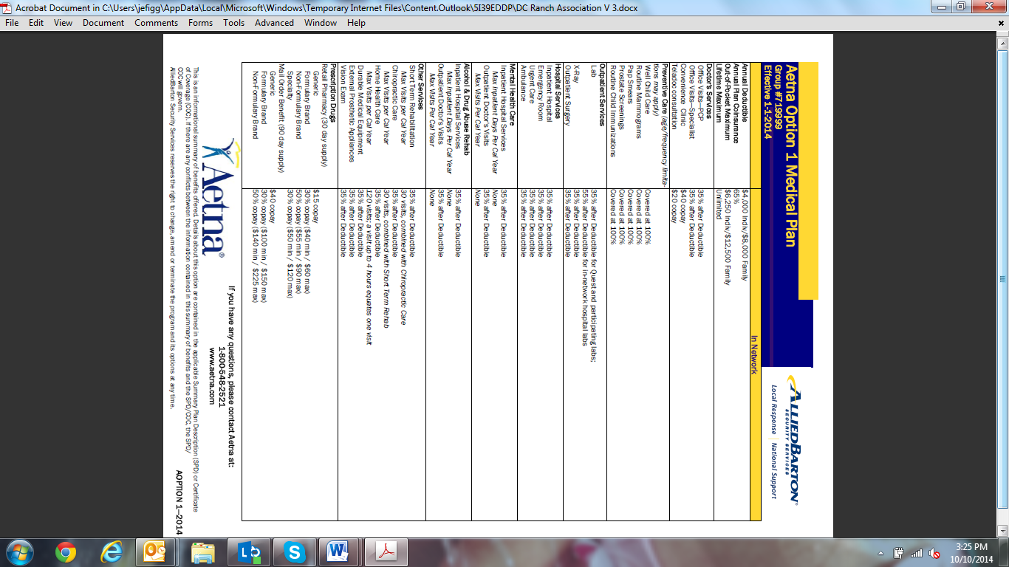

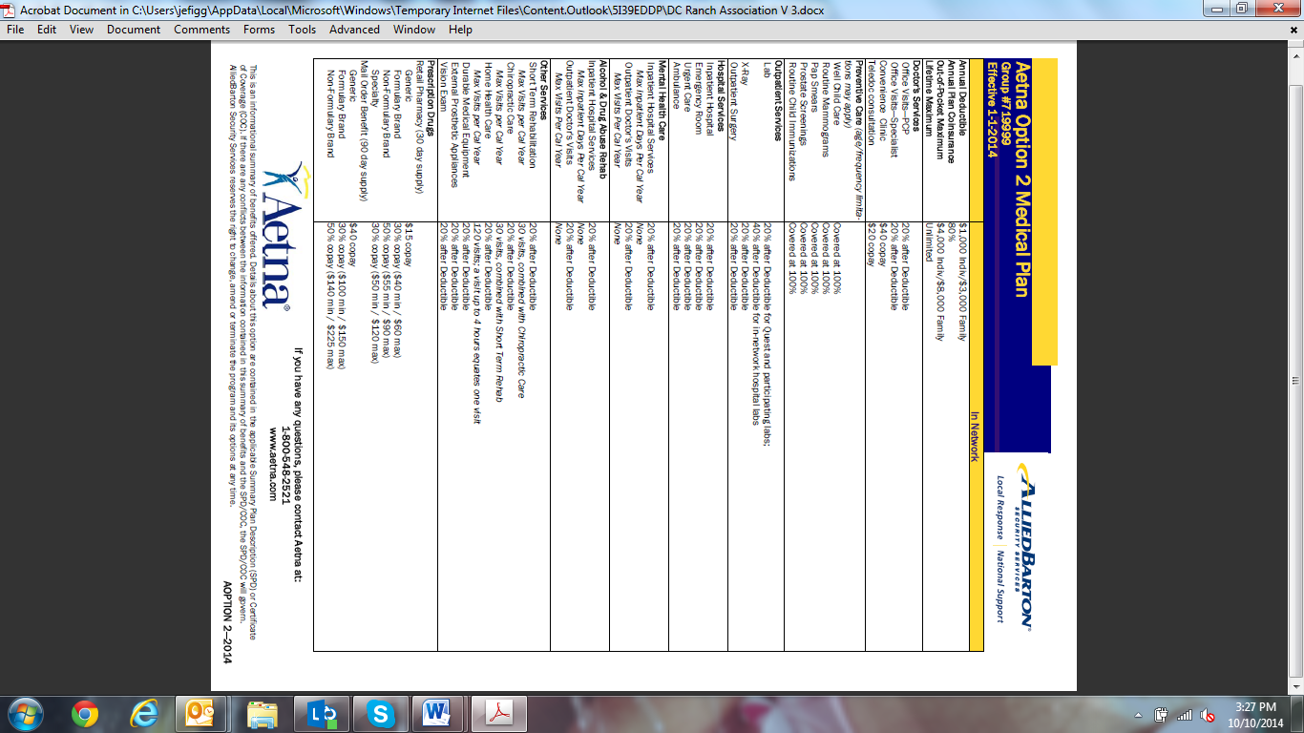

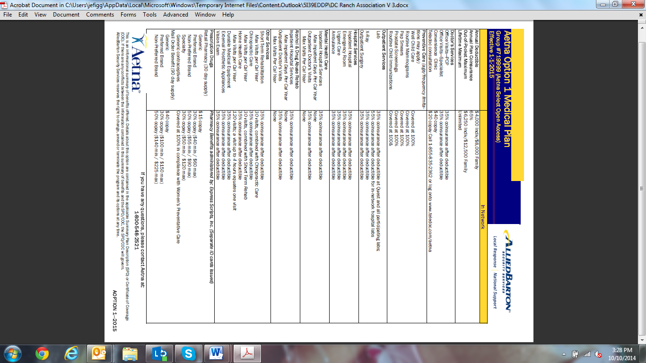

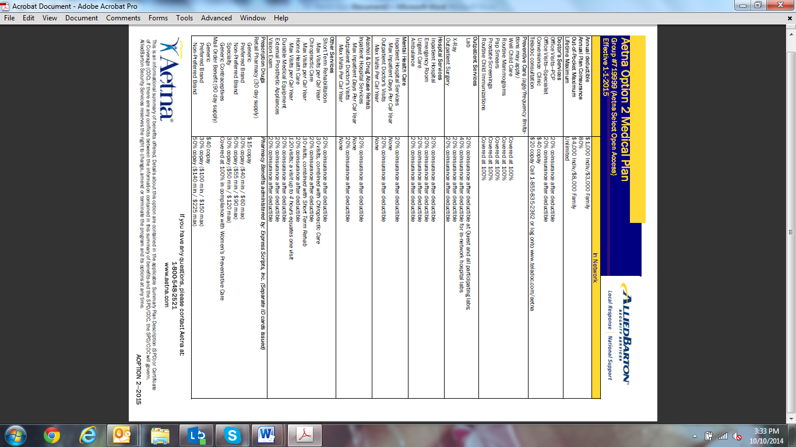

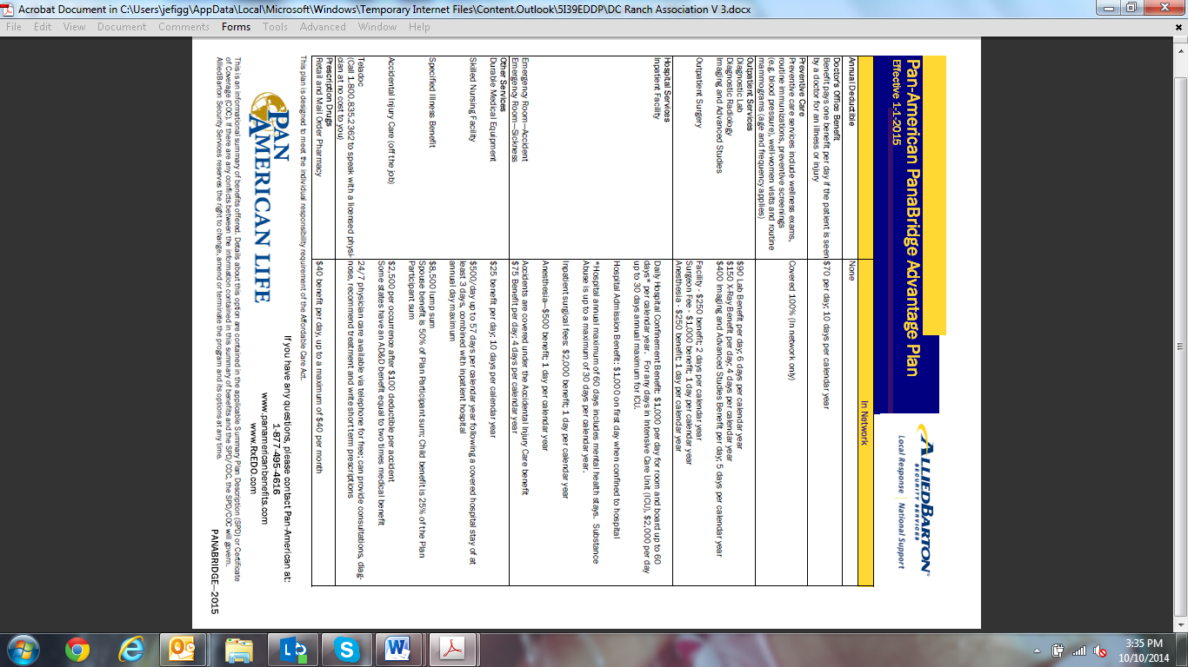

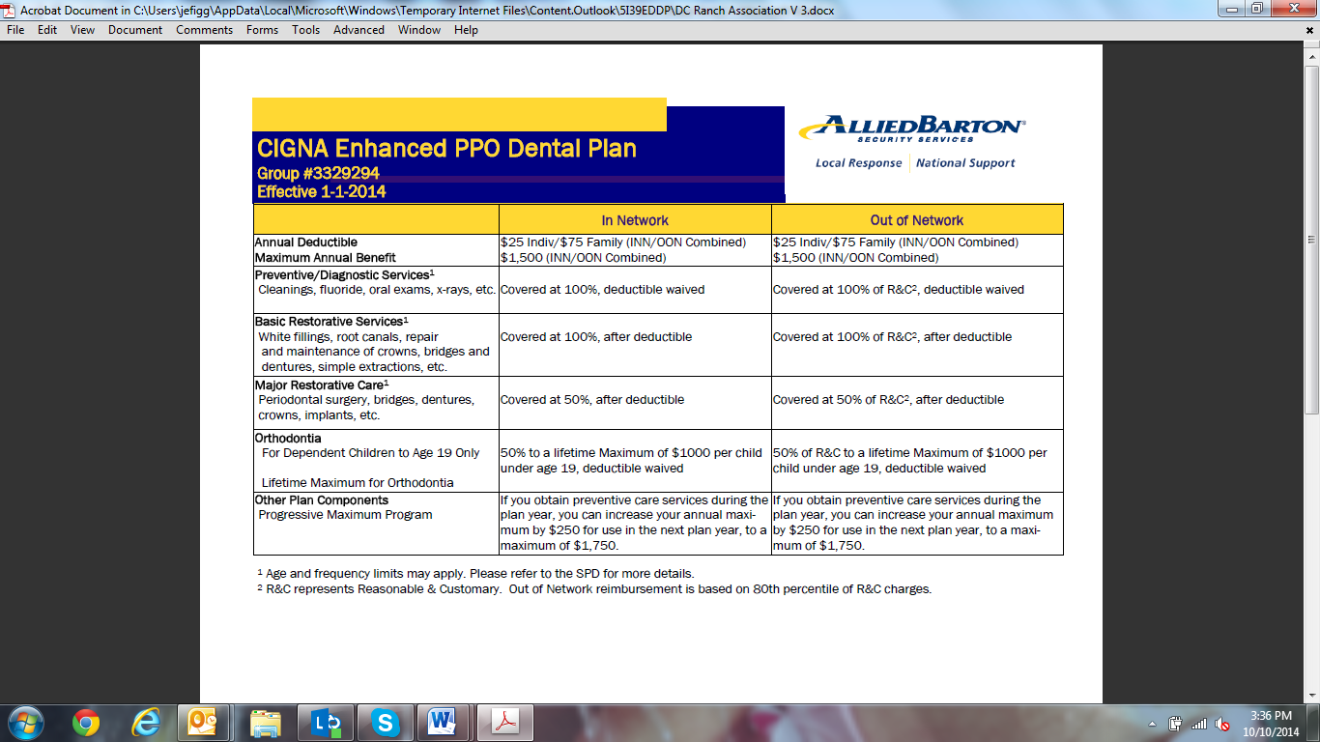

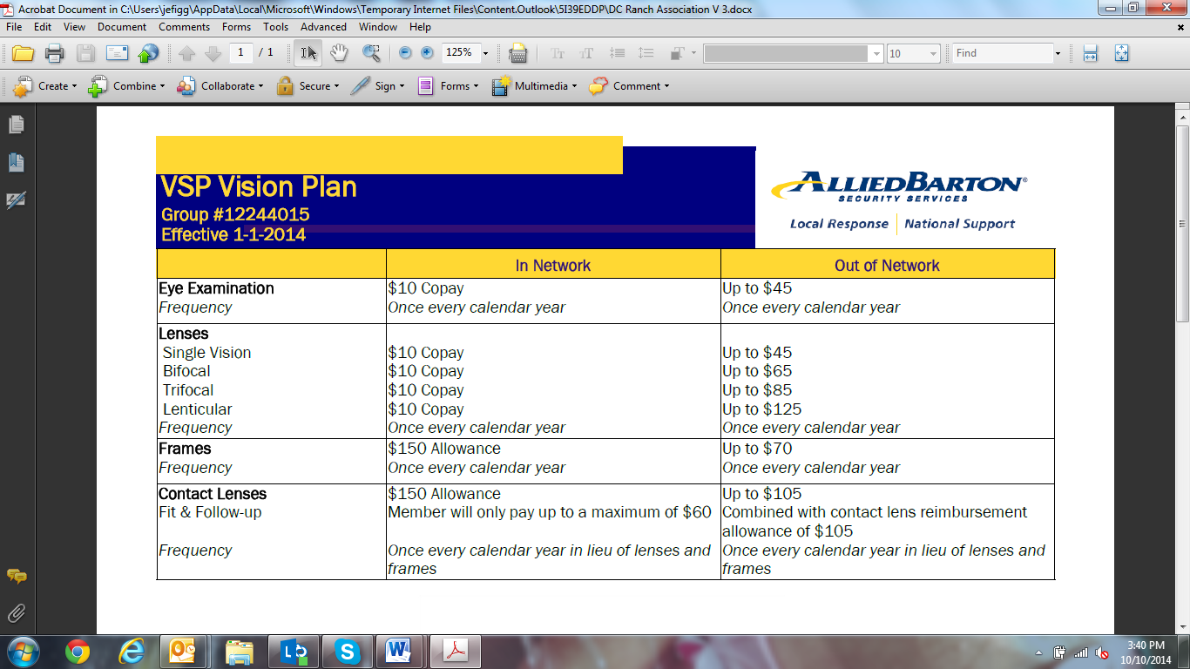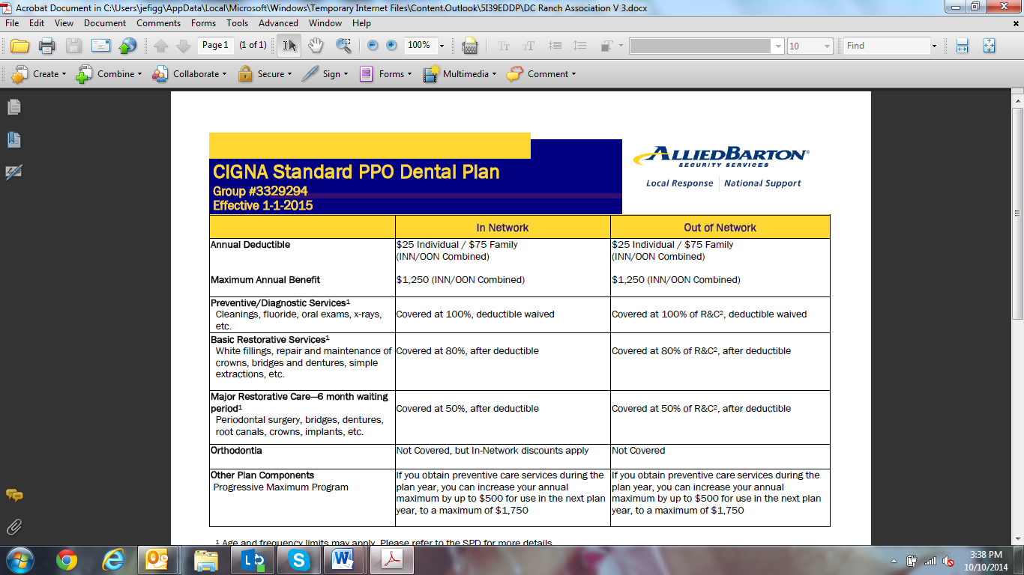

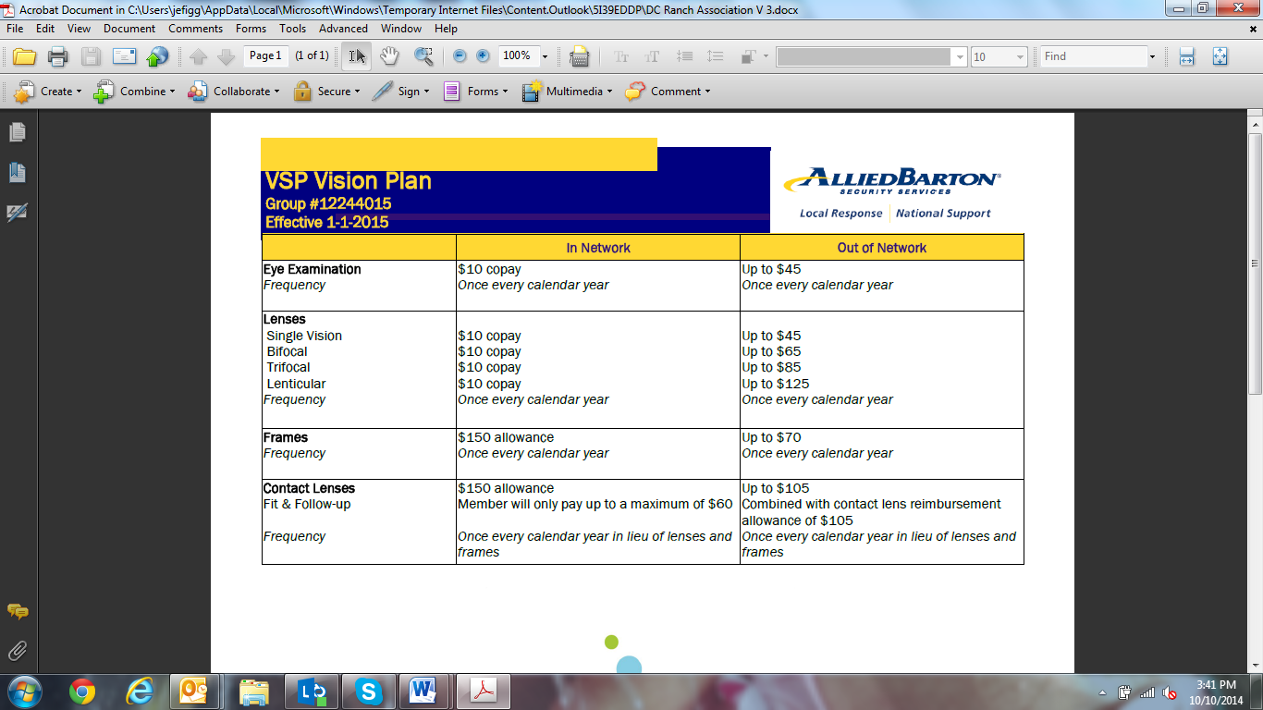







Comprehensive Background and Screening Process

|  |  |
| --- | --- |
| **Application Review & Assessment** | Careful analysis focuses on employment history and stability. The application includes a questionnaire utilized to assess writing skills and determine whether an applicant’s personal character is in-line with the company’s values. |
| **Interviews** | The initial in-person interview assesses punctuality and appearance and clarifies points of the candidate’s application. Multiple interviews may be conducted, and candidates progressing beyond this level will attend our orientation and training program. |
| **Education and Employment Verification (Reference Checks)** | AlliedBarton verifies high school diplomas or GED or highest degrees obtained, a minimum of two previous employers including military DD214 and current employer (after an offer is extended). |
| **Electronic I-9** | Employment verification must be completed for all AlliedBarton employees to present proof of citizenship or authorized alien status. All potential employees are processed through E-Verify, the government’s employment eligibility system, as well. |
| **Management Testing** | Management testing may involve the Thomas Personal Profile Analysis, The Kenexa Manager assessment or The Kenexa Leadership assessment, depending on the position. These help assess candidates’ management abilities, drive, maturity and people skills, and evaluate whether they are a good fit. |
| **Criminal Background Checks** | Prior to being hired, each employee undergoes a comprehensive criminal records check. Where required, fingerprints are taken and submitted to the appropriate law enforcement agency for a detailed background investigation. Statewide criminal checks are also conducted when required. AlliedBarton will only hire individuals who are suitable for employment in the positions for which they are being hired and who are eligible to hold a security guard license where required by state law. Our stringent pre-hire standards include: no felony convictions, no major misdemeanors, no arrests with prosecution pending, and no dishonorable discharge (where permitted by state law). |
| **Social Security Checks** | As an additional measure of precaution, we run Social Security checks on each candidate to verify their identity. |
| **Pre-employment Drug Testing** | All AlliedBarton candidates, as permitted by law, undergo a five-panel drug test prior to hire to screen for marijuana, cocaine, amphetamines, morphine and PCP. Preferred five-panel testing is either on-site urine or oral fluid (depending on state and contractual requirements). In states that do not allow on-site urine or oral fluid testing, we offer Intercept, an oral fluid device administered on-site with the results conducted by the lab. On-site ten-panel tests, off-site five-panel or ten-panel tests, hair follicle and alcohol testing are available at an additional charge. |
| **Motor Vehicle Report** | Officers designated to drive a vehicle are subject to Motor Vehicle Report checks and on-site training before they can operate a vehicle. |
| **Security Officer Integrity/Honesty Testing** | AlliedBarton offers the Reid Test for security officer integrity/honesty testing. This selection assessment tool evaluates attitudes and behaviors associated with high levels of integrity and productive work habits. AlliedBarton offers a discounted rate through a commercial arrangement. |

| **Partnership** | **WorkPerks Benefit** |
| --- | --- |
|  | |
| **Blackstone Marketplace** | An exclusive savings program with discounts from over 28,000 merchants on everything from groceries, movie tickets, clothes and accessories to electronics, vacations and personal care items. |
| **H&R Block** | In-Office Services \* - $15 discount off of Tax Preparation - Free Second Look® Review2   Online and Software - Receive special pricing on H&R Block online and software tax preparation products |
| **Hilton Hotels** | 12% discount off Best Available Rate at all Hilton Family Hotels around the world, except the high destination cities where the offer is 20% off Best Available Rate. |
| **La Quinta Hotels** | 15% discount at participating La Quinta hotels. |
| **COSTCO Wholesale Club** | Join fee of $50 and coupons valued at more than $50 including free items. |
| **Verizon Wireless** | 20% off monthly access plans and 25% off eligible accessories. Saving on cost with Friends and Family® Talk! The latest devices at competitive and exclusive prices. |
| **Sprint/Nextel** | 20% off Sprint or Nextel monthly access charge. |
| **AT&T** | 22% discount on qualified voice and data plans with AT&T Mobility. |
| **DIRECTV** | $29.99/month.  $60 cash back from DirectStarTV plus free installation for up to 4 rooms. |
| **Mitsubishi Motors VIP Purchase Program** | Discounted price for new Mitsubishi vehicles (for full time employees). |
| **GlobalFit** | Discounted month-to-month membership. |
| **Police & Fire Federal Credit Union** | Free checking, direct deposit, online bill-pay, loans, etc. (for full time employees). |
| **Dell Computers** | Special discounts. |
| **Hewlett Packard** | Discounts up to 15% off list price. Also eligible for national mail-in and instant rebates, coupons and exclusive EPP deals in addition to the discount. |
| **JoS. A Bank Clothiers** | Free corporate card w/20% discount off regularly priced merchandise. |
| **Shoes for Crews** | Discounted prices. |
| **VPI® Pet Insurance** | 5% discount on pet insurance. |
| **From You Flowers** | 20% on all regularly priced floral and gift items. |
| **Working Advantage** | Offers discounts on a variety of merchants including shopping, entertainment, theme parks, and theatre and movie tickets, gifts, etc. |